|  |  |  |  |  |  |  |
| --- | --- | --- | --- | --- | --- | --- |
| |  |  |  |  | | --- | --- | --- | --- | |  | | **MINISTRY OF EDUCATION AND TRAINING** | | | **FPT UNIVERSITY** | | |
| Capstone Project Document |
| Online Medical Consultant System |
| |  |  |  |  |  |  |  |  |  |  |  | | --- | --- | --- | --- | --- | --- | --- | --- | --- | --- | --- | | |  |  | | --- | --- | | **Group 02 – Report 04** | | | **Group member** | Trần Nguyên Tiến Sứ - Team Leader - SE60781  Trần Cao Danh - Team Member - SE60705 | | **Supervisor** | Mr. Nguyễn Huy Hùng | | **Ext. Supervisor** | N/A | | **Capstone Project code** | OMCS | | |
| * Ho Chi Minh City, 20 June / 2014 – |

Table of Contents

List of Tables 3

No table of figures entries found.List of Figures 3

Definitions, Acronyms, and Abbreviations 4

A. Report No.4: Software Design Description (SDD) 5

1. Design Overview 5

2. System Architectural Design 6

2.1 Choice of system architecture 6

2.2 Description of System Interface 6

3. Component Diagram 7

4. Detailed Description of Components 8

4.1 Class Diagram 8

5. Sequence Diagram 9

5.1 <Guest> Login 9

5.2 <Guest> Register 9

5.3 <Authorized User> Change Password 10

5.4 <Authorized User> Change Profile Picture 11

5.5 <Patient> Conversation 12

5.6 <Doctor> Request Webcam 13

5.7 <Patient> Upload Attachment 13

5.8 <Admin> Define New Medical Profile Template 14

5.9 <Admin> Update Medical Profile Template 15

5.10 <Doctor> Update Medical Profile 16

5.11 <Doctor> Views Medical Profile 17

5.12 <Patient> Update Personal Health Record 17

5.13 <Patient> View Medical Profile 18

6. User Interface Design 18

7. Database Design 18

# List of Tables

# No table of figures entries found.List of Figures

Figure 1: MVC Architecture 6

Figure 2: Component Diagram 7

Figure 3: Class Diagram 8

Figure 4: <Guest> Login Sequence Diagram 9

Figure 5: <Guest> Register Sequence Diagram 10

Figure 6: <Authorized User> Change Password Sequence Diagram 11

Figure 7: <Authorized User> Change Profile Picture Sequence Diagram 11

Figure 8: <Patient> Conversation Sequence Diagram 12

Figure 9: <Doctor> Request Webcam Sequence Diagram 13

Figure 10: <Patient> Upload Attachment 13

Figure 11 <Admin> Define New Medical Profile Template 14

Figure 12 <Admin> Update Medical Profile Template 15

Figure 13: <Doctor> Update Medical Profile 16

Figure 14: <Doctor> Views Medical Profile 17

Figure 15: <Patient> Update Personal Health Record 17

# Definitions, Acronyms, and Abbreviations

# 

# Report No.4: Software Design Description (SDD)

## Design Overview

* This document describes the technical and user interface design of OMCS system. It includes the architectural design, the detailed design of common functions and business functions and the design of database model.
* The architectural design describes the overall architecture of the system and the architecture of each main component.
* The detailed design describes static and dynamic structure for each component and functions. It includes class diagrams, class explanations and sequence diagrams for each use cases.
* The database design describes the relationships between entities and details of each entity.

## System Architectural Design

### Choice of system architecture



Figure : MVC Architecture

**(http://smist08.wordpress.com/tag/mvc/)**

**The Model** is the part of the application that handles the logic for the application data.  
Often model objects retrieve data (and store data) from a database.

**The View** is the parts of the application that handles the display of the data.  
Most often the views are created from the model data.

**The Controller** is the part of the application that handles user interaction.  
Typically controllers read data from a view, control user input, and send input data to the model.

**(**<http://www.w3schools.com/aspnet/mvc_intro.asp>**)**

## Component Diagram



Figure 2: Component Diagram

## Detailed Description of Components

### Class Diagram

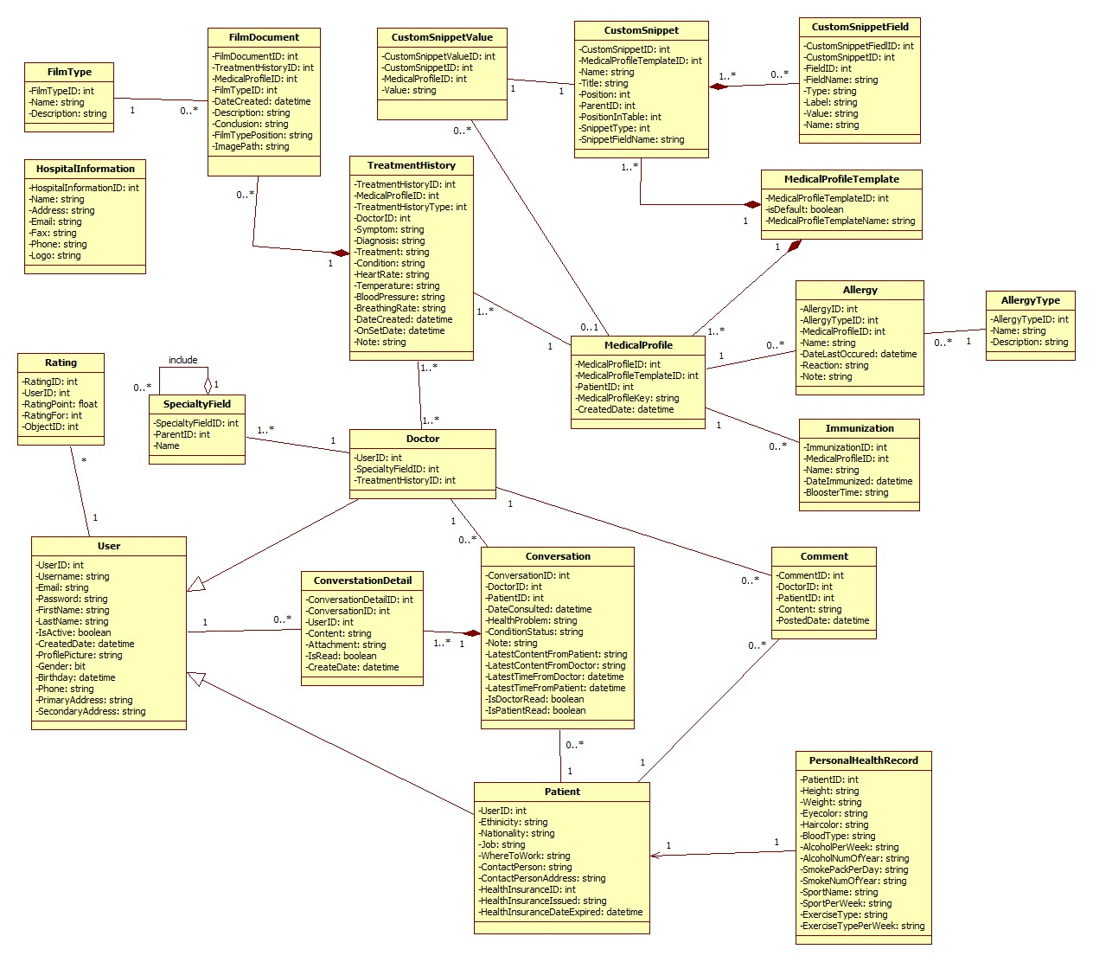

Figure 3: Class Diagram

### Class Diagram Explanation

#### User Model

|  |  |  |  |
| --- | --- | --- | --- |
| **Attribute Name** | **Type** | **Visibility** | **Description** |
| UserID | int | public | ID of the user |
| Username | string | public | User name of the user |
| Email | string | public | Email of the user |
| Password | string | public | Password of the user |
| FirstName | string | public | First name of the user |
| LastName | string | public | Last name of the user |
| IsActive | boolean | public | Condition of the user’s account |
| CreatedDate | datetime | public | Created date of the user’s account |
| ProfilePicture | string | public | Profile picture name of the user |
| Gender | string | public | Gender of the user |
| Birthday | datetime | public | Birthday of the user |
| Phone | string | public | Phone of the user |
| PrimaryAddress | string | public | Primary address of the user |
| SecondaryAddress | string | public | Secondary address of the user |

#### SpecialtyField Model

|  |  |  |  |
| --- | --- | --- | --- |
| **Attribute Name** | **Type** | **Visibility** | **Description** |
| SpecialtyFieldID | int | public | ID of the specialty field |
| ParentID | int | public | Parent id of the specialty field |
| Name | string | public | Name of the specialty field |

#### HospitalInformation Model

|  |  |  |  |
| --- | --- | --- | --- |
| **Attribute Name** | **Type** | **Visibility** | **Description** |
| HospitalInformationID | int | public | ID of the hospital |
| Name | string | public | Name of the hospital |
| Address | string | public | Address of the hospital |
| Email | string | public | Email of the hospital |
| Fax | string | public | Fax of the hospital |
| Phone | string | public | Phone of the hospital |
| Logo | string | public | Logo of the hospital |

#### FilmType Model

|  |  |  |  |
| --- | --- | --- | --- |
| **Field Name** | **Type** | **Visibility** | **Description** |
| FilmTypeID | int | public | ID of the film type |
| Name | string | public | Name of the film type |
| Description | string | public | Description of the film type |

#### FilmDocument Model

|  |  |  |  |
| --- | --- | --- | --- |
| **Field Name** | **Type** | **Visibility** | **Description** |
| FilmDocumentID | int | public | ID of the film document |
| TreatmentHistoryID | int | public | ID of the treatment history |
| MedicalProfileID | int | public | ID of the medical profile |
| FilmTypeId | int | public | ID of the film type |
| DateCreated | datetime | public | Date created of the film document |
| Description | string | public | Position of the film type |
| Conclusion | string | public | Path of the image |
| FilmTypePosition | string | public | Position of the film type |
| ImagePath | string | public | Path of the image |

#### CustomSnippetValue Model

|  |  |  |  |
| --- | --- | --- | --- |
| **Field Name** | **Type** | **Visibility** | **Description** |
| CustomSnippetValueID | int | public | ID of the custom snippet value |
| CustomSnippetID | int | public | ID of the custom snippet |
| MedicalProfileID | int | public | ID of the medical profile |
| Value | string | public | Value of the custom snippet |

#### TreatmentHistory Model

|  |  |  |  |
| --- | --- | --- | --- |
| **Field Name** | **Type** | **Visibility** | **Description** |
| TreatmentHistoryID | int | public | ID of the treatment history |
| MedicalProfileID | int | public | ID of the medical profile |
| TreatmentHistoryType | int | public | ID of the treatment history type |
| DoctorID | int | public | ID of the doctor |
| Symptom | string | public | Symptom of the treatment history |
| Diagnosis | string | public | Diagnosis of the treatment history |
| Treatment | string | public | Treatment of the treatment history |
| Condition | string | public | Condition of the treatment history |
| HeartRate | string | public | Heart rate of the treatment history |
| Temperature | string | public | Temperature of the treatment history |
| BloodPressure | string | public | Blood pressure of the treatment history |
| BreathingRate | string | public | Breathing rate of the treatment history |
| DateCreated | datetime | public | Created date of the treatment history |
| OnSetDate | datetime | public | Set date of the treatment history |
| Note | string | public | Note of the treatment history |

#### Doctor Model

|  |  |  |  |
| --- | --- | --- | --- |
| **Field Name** | **Type** | **Visibility** | **Description** |
| UserID | int | public | ID of the user |
| SpecialtyFieldID | int | public | ID of the specialty field |
| TreatmentHistoryID | int | public | ID of the treatment history |

#### ConversationDetail Model

|  |  |  |  |
| --- | --- | --- | --- |
| **Field Name** | **Type** | **Visibility** | **Description** |
| ConversationDetailID | int | public | ID of the conversation detail |
| ConversationID | int | public | ID of the conversation |
| UserID | int | public | ID of the user |
| Content | string | public | Content of the conversation detail |
| Attachment | string | public | Attachment of the conversation detail |
| IsRead | bit | public | Conversation detail is read |
| CreatedDate | datetime | public | Created date of the conversation detail |

#### CustomSnippet Model

|  |  |  |  |
| --- | --- | --- | --- |
| **Field Name** | **Type** | **Visibility** | **Description** |
| CustomSnippetID | int | public | ID of the custom snippet |
| MedicalProfileTemplateID | int | public | ID of the medical profile template |
| Name | string | public | Name of the custom snippet |
| Title | string | public | Title of the custom snippet |
| Position | int | public | Position of the custom snippet |
| ParentId | int | public | Parent id of the custom snippet |
| PositionInTable | int | public | Position in table of the custom snippet |
| SnippetType | int | public | Snippet type of the custom snippet |
| SnippetFieldName | string | public | Name of the snippet field |

#### MedicalProfileTemplate Model

|  |  |  |  |
| --- | --- | --- | --- |
| **Field Name** | **Type** | **Visibility** | **Description** |
| MedicalProfileTemplateID | int | public | ID of the medical profile template |
| IsDefault | string | public | Medical profile template is default |
| MedicalProfileTemplateName | string | public | Name of the medical profile template |

#### MedicalProfile Model

|  |  |  |  |
| --- | --- | --- | --- |
| **Field Name** | **Type** | **Visibility** | **Description** |
| MedicalProfileID | int | public | ID of the medical profile |
| MedicalProfileTemplateID | int | public | ID of the medical profile template |
| ParentID | int | public | Parent id of the medical profile |
| MedicalProfileKey | string | public | Key of the medical profile |
| DateCreated | datetime | public | Created date of the medical profile |

#### Conversation Model

|  |  |  |  |
| --- | --- | --- | --- |
| **Field Name** | **Type** | **Visibility** | **Description** |
| ConversationID | int | public | ID of the conversation |
| PatientID | int | public | ID of the patient |
| DoctorID | int | public | ID of the doctor |
| DateConsulted | datetime | public | Consulted date of the conversation |
| HealthProblem | string | public | Health problem of the conversation |
| Note | string | public | Note of the conversation |
| LatestContentFromPatient | string | public | Latest content from patient of the conversation |
| LatestContentFromDoctor | string | public | Latest content from doctor of the conversation |
| LatestTimeFromDoctor | datetime | public | Latest time from doctor of the conversation |
| LatestTimeFromPatient | datetime | public | Latest time from patient of the conversation |
| IsDoctorRead | bit | public | Doctor is read |
| IsPatientRead | bit | public | Patient is read |

#### Comment Model

|  |  |  |  |
| --- | --- | --- | --- |
| **Field Name** | **Type** | **Visibility** | **Description** |
| CommentID | int | public | ID of the comment |
| PatientID | int | public | ID of the patient |
| DoctorID | int | public | ID of the doctor |
| Content | string | public | Content of the comment |
| PostedDate | datetime | public | Posted date of the comment |

#### CustomSnippetField Model

|  |  |  |  |
| --- | --- | --- | --- |
| **Field Name** | **Type** | **Visibility** | **Description** |
| CustomSnippetFieldID | int | public | ID of the custom snippet field |
| CustomSnippetID | int | public | ID of the custom snippet |
| FieldID | int | public | ID of the field |
| FieldName | string | public | Field name of the custom snippet field |
| Type | string | public | Type of the custom snippet field |
| Label | string | public | Label of the custom snippet field |
| Value | string | public | Value of the custom snippet field |
| Name | string | public | Name of the custom snippet field |

#### Rating Model

|  |  |  |  |
| --- | --- | --- | --- |
| **Field Name** | **Type** | **Visibility** | **Description** |
| RatingID | int | public | ID of the rating |
| UserId | int | public | ID of the user |
| RatingPoint | float | public | Point of the rating |
| RatingFor | int | public | Rating for of the rating |
| ObjectId | int | public | ID object of the rating |

#### Allergy Model

|  |  |  |  |
| --- | --- | --- | --- |
| **Field Name** | **Type** | **Visibility** | **Description** |
| AllergyID | int | public | ID of the allergy |
| MedicalProfileID | int | public | ID of the medical profile |
| AllergyTypeID | datetime | public | ID of the allergy type |
| Name | string | public | Name of the allergy |
| DateLastOccurred | datetime | public | Last occurred date of the allergy |
| Reaction | string | public | Reaction of the allergy |
| Note | string | public | Note of the allergy |

#### Immunization Model

|  |  |  |  |
| --- | --- | --- | --- |
| **Field Name** | **Type** | **Visibility** | **Description** |
| ImmunizationId | int | public | ID of the immunization |
| MedicalProfileID | int | public | ID of the medical profile |
| Name | string | public | Name of the immunization |
| DateImmunized | datetime | public | Immunized date |
| BoosterTime | int | public | Booster time |

#### PersonalHealthRecord Model

|  |  |  |  |
| --- | --- | --- | --- |
| **Field Name** | **Type** | **Visibility** | **Description** |
| PatientId | int | public | ID of the patient |
| Height | float | public | Height of the patient |
| Weight | float | public | Weight of the patient |
| EyeColor | string | public | Eye color of the patient |
| HairColor | string | public | Hair color of the patient |
| BloodType | string | public | Blood type of the patient |
| AlcoholPerWeek | float | public | Alcohol per week of the patient |
| AlcoholNumOfYear | int | public | Alcohol number of year of the patient |
| IsBeer | bit | public | Is beer of the patient |
| SmokePackPerWeek | float | public | Smoke pack per week of the patient |
| SmokeNumOfYear | int | public | Smoke number of year of the patient |
| SportName | string | public | Sport name of the patient |
| SportPerWeek | string | public | Sport per week of the patient |
| ExerciseType | string | public | Exercise type of the patient |
| ExercisePerWeek | int | public | Exercise per week of the patient |

#### AllergyType Model

|  |  |  |  |
| --- | --- | --- | --- |
| **Field Name** | **Type** | **Visibility** | **Description** |
| AllergyTypeID | int | public | ID of the allergy type |
| Name | float | public | Name of the allergy type |
| Description | float | public | Description of the allergy type |

#### Patient Model

|  |  |  |  |
| --- | --- | --- | --- |
| **Field Name** | **Type** | **Visibility** | **Description** |
| UserID | int | public | ID of the user |
| Ethnicity | string | public | Ethnicity of the patient |
| Nationality | string | public | Nationality of the patient |
| Job | string | public | Job of the patient |
| WhereToWork | string | public | Where to work of the patient |
| ContactPerson | string | public | Contact person of the patient |
| ContactPersonAddress | string | public | Contact person address of the patient |
| ContactPersonPhone | string | public | Contact person phone of the patient |
| HealthInsuranceId | int | public | Health insurance id of the patient |
| HealthInsuranceIssued | datetime | public | Health insurance issued of the patient |
| HealthInsuranceDateExpired | datetime | public | Health insurance date expired of the patient |

## Sequence Diagram

### <Guest> Login



Figure 4: <Guest> Login Sequence Diagram

### <Guest> Register



Figure 5: <Guest> Register Sequence Diagram

### <Authorized User> Change Password



Figure 6: <Authorized User> Change Password Sequence Diagram

### <Authorized User> Change Profile Picture



Figure 7: <Authorized User> Change Profile Picture Sequence Diagram

### <Patient> Conversation



Figure : <Patient> Conversation Sequence Diagram

### <Doctor> Request Webcam



Figure 9: <Doctor> Request Webcam Sequence Diagram

### <Patient> Upload Attachment



Figure 10: <Patient> Upload Attachment

### <Admin> Define New Medical Profile Template



Figure <Admin> Define New Medical Profile Template

### <Admin> Update Medical Profile Template



Figure 12 <Admin> Update Medical Profile Template

### <Doctor> Update Medical Profile

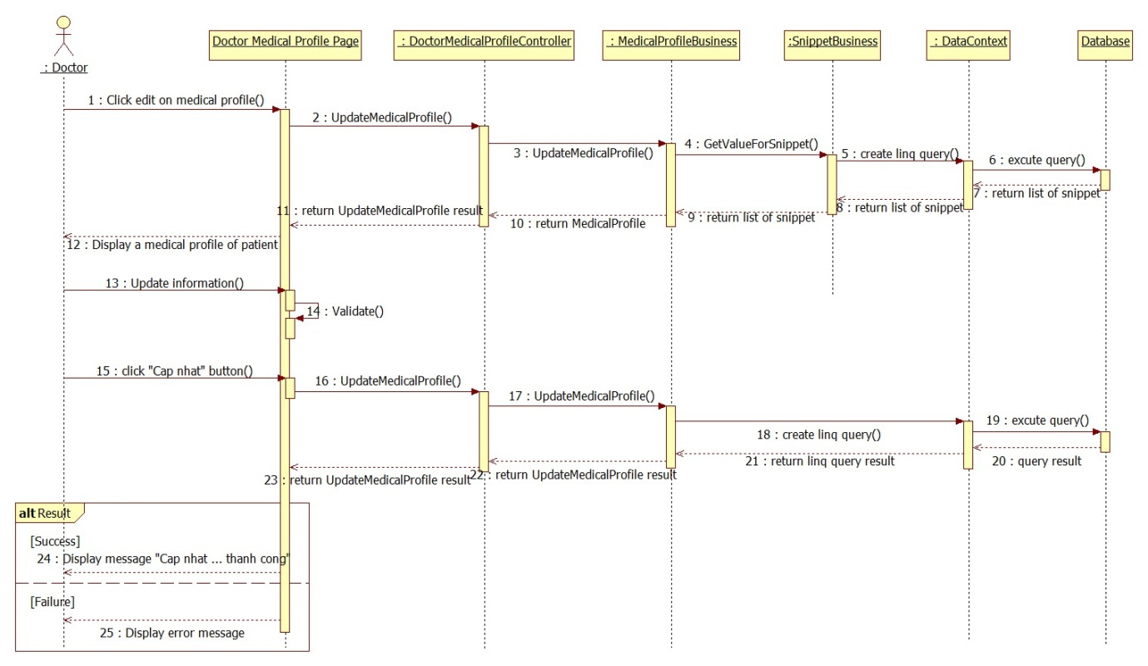

Figure : <Doctor> Update Medical Profile

### <Doctor> Views Medical Profile



Figure 14: <Doctor> Views Medical Profile

### <Patient> Update Personal Health Record



Figure : <Patient> Update Personal Health Record

### <Patient> View Medical Profile



Figure 9: <Patient> View Medical Profile Record

## User Interface Design

### HOMEPAGE SCREEN

#### Screen Images

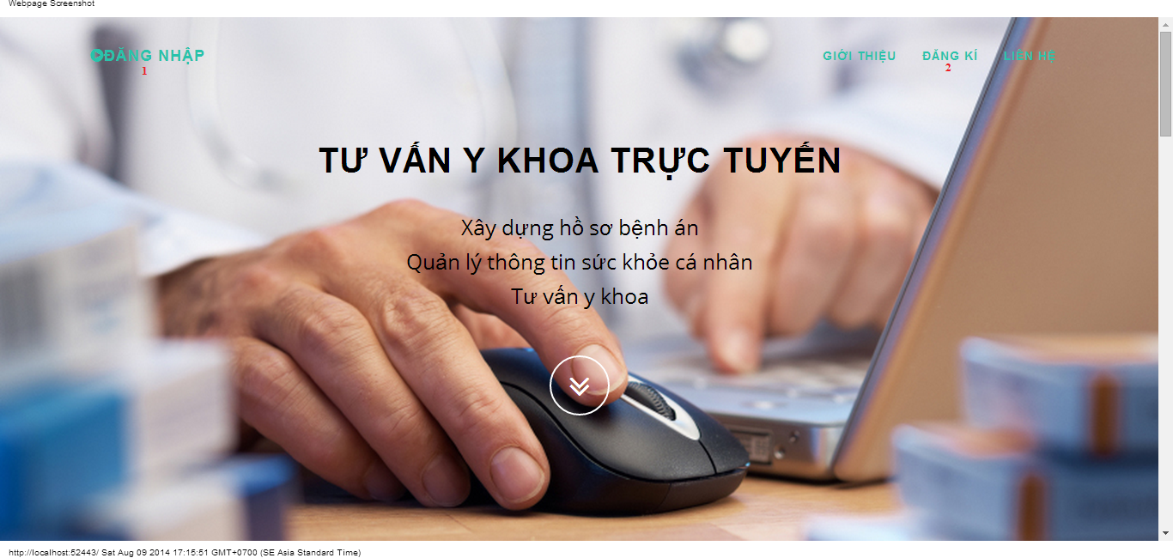

#### Objects and Actions

#### Data fields

|  |  |  |  |  |  |  |
| --- | --- | --- | --- | --- | --- | --- |
| **Field No** | **Field name** | **Type** | **Mandatory** | **Data type** | **Max length** | **Description** |

#### Actions

|  |  |  |  |  |  |
| --- | --- | --- | --- | --- | --- |
| **Field No** | **Field name** | **Type** | **Action** | **Description** | **Validation** |
| 1 | Đăng nhập | Link | On click | Forward to “Login” page |  |
| 2 | Đăng kí | Link | On click | Forward to “Register” page |  |

### LOGIN SCREEN

#### Screen image

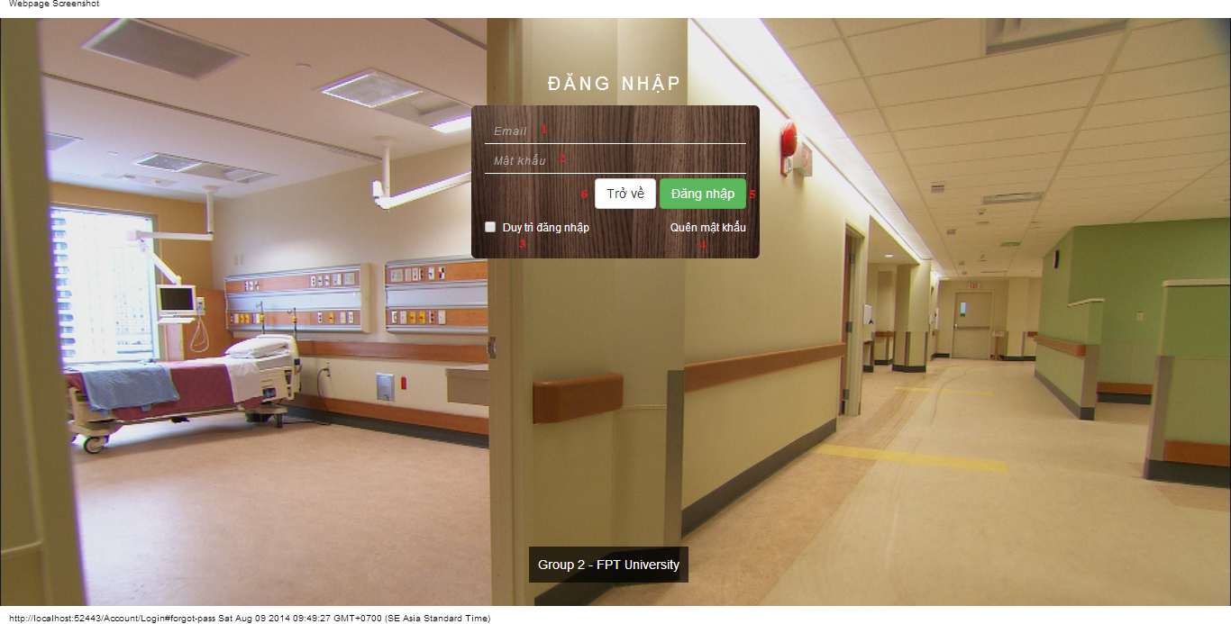

#### Objects and Actions

#### Data fields

|  |  |  |  |  |  |  |
| --- | --- | --- | --- | --- | --- | --- |
| **Field No** | **Field name** | **Type** | **Mandatory** | **Data type** | **Max length** | **Description** |
| 1 | Email | Textbox | Yes | String |  | Contain user’s email to login |
| 2 | Mật khẩu | Textbox | Yes | String |  | Contain user’s password to login |
| 3 | Duy trì đăng nhập | Checkbox | No | Boolean |  | Check to remember user to login again |

#### Actions

|  |  |  |  |  |  |
| --- | --- | --- | --- | --- | --- |
| **Field No** | **Field name** | **Type** | **Action** | **Description** | **Validation** |
| 4 | Quên mật khẩu | Link | On click | Forward to popup “ForgotPassword”. |  |
| 5 | Đăng nhập | Button | On click | Forward to page follow user’s role. | Email and password not empty |
| 6 | Trở về | Button | On click | Cancel the login. Back to previous page. |  |

### REGISTER SCREEN

#### Screen image

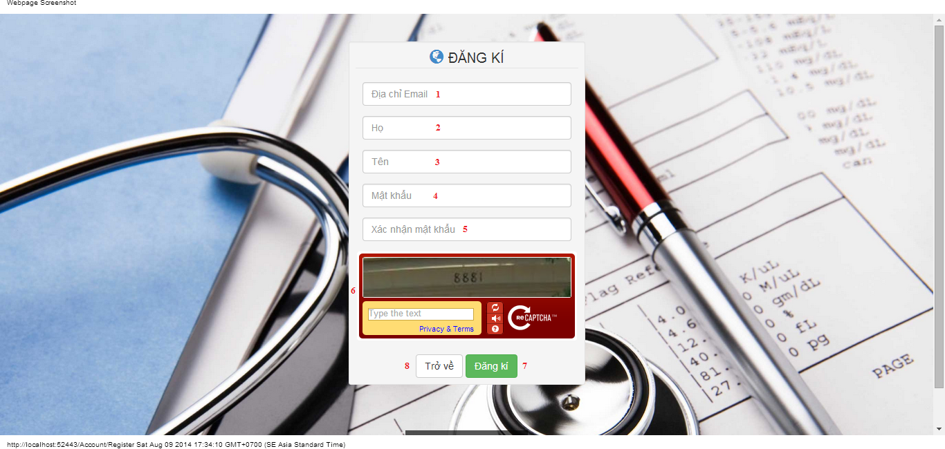

#### Objects and Actions

#### Data fields

|  |  |  |  |  |  |  |
| --- | --- | --- | --- | --- | --- | --- |
| **Field No** | **Field name** | **Type** | **Mandatory** | **Data type** | **Max length** | **Description** |
| 1 | Địa chỉ Email | Textbox | Yes | String | 50 | Contain user’s email to login |
| 2 | Họ | Textbox | Yes | String | 25 | Contain user’s last name |
| 3 | Tên | Textbox | Yes | String | 25 | Contain user’s first name |
| 4 | Mật khẩu | Textbox | Yes | String | 25 | Contain user’s password to login |
| 5 | Xác nhận mật khẩu | Textbox | Yes | String | 25 | Contain the confirm password |
| 6 | Retype Image | Textbox | Yes | String |  | Contain the verifying captcha |

#### Actions

|  |  |  |  |  |  |
| --- | --- | --- | --- | --- | --- |
| **Field No** | **Field name** | **Type** | **Action** | **Description** | **Validation** |
| 7 | Đăng kí | Button | On click | Submit inputted data to server | Inputted data must be valid |
| 8 | Trở về | Button | On click | Cancel the registration. Back to previous page |  |

### FORGOT PASSWORD SCREEN

#### Screen image

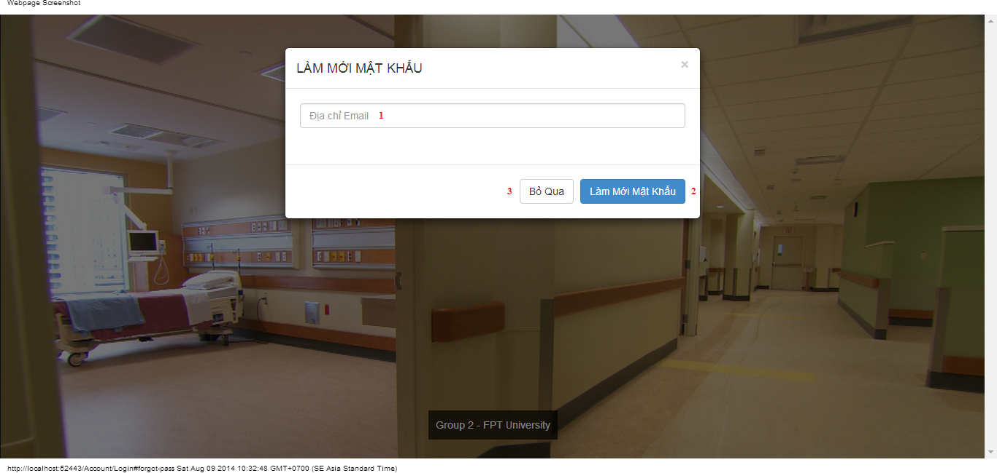

#### Objects and Actions

#### Data fields

|  |  |  |  |  |  |  |
| --- | --- | --- | --- | --- | --- | --- |
| **Field No** | **Field name** | **Type** | **Mandatory** | **Data type** | **Max length** | **Description** |
| 1 | Địa chỉ Email | Textbox | Yes | String |  | Contain user’s email to reset password |

#### Actions

|  |  |  |  |  |  |
| --- | --- | --- | --- | --- | --- |
| **Field No** | **Field name** | **Type** | **Action** | **Description** | **Validation** |
| 2 | Làm mới mật khẩu | Button | On click | Submit inputted data to server | Inputted data must be valid |
| 3 | Bỏ qua | Button | On click | Dismiss model. Back to login page |  |

### ADMIN HOSPITAL INFORMATION SCREEN

#### Screen image

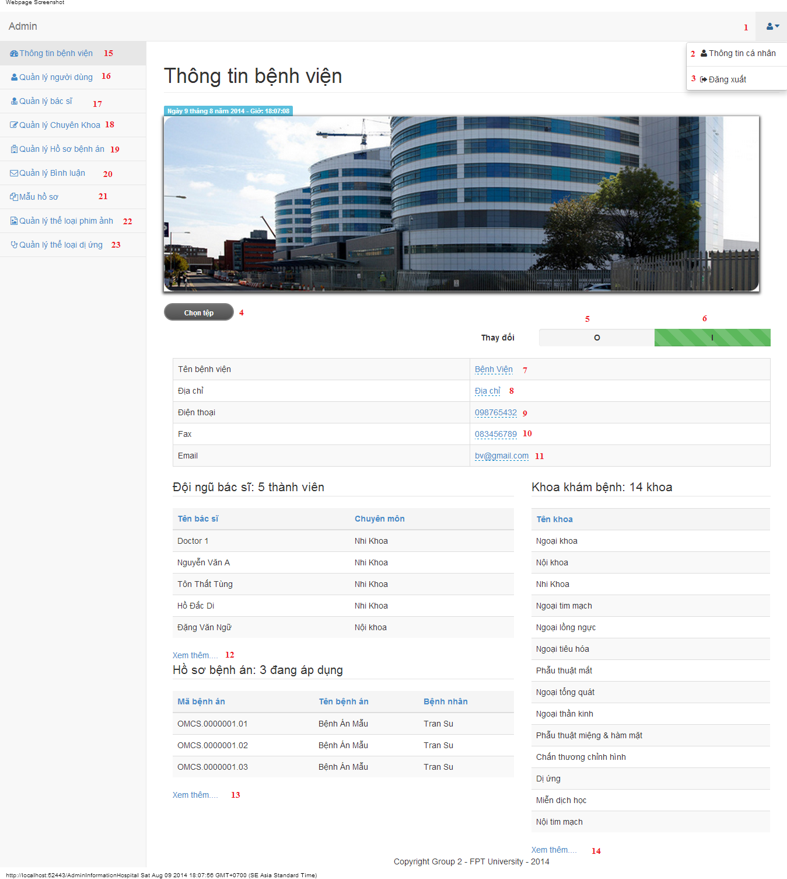

#### Objects and Actions

#### Data fields

|  |  |  |  |  |  |  |
| --- | --- | --- | --- | --- | --- | --- |
| **Field No** | **Field name** | **Type** | **Mandatory** | **Data type** | **Max length** | **Description** |
| 7 | Tên bệnh viện | Textbox | Yes | String | 50 | Contain hospital’s name |
| 8 | Địa chỉ | Textbox | Yes | String | 50 | Contain hospital’s address |
| 9 | Điện thoại | Textbox | Yes | String | 12 | Contain hospital’s phone |
| 10 | Fax | Textbox | Yes | String | 12 | Contain hospital’s fax |
| 11 | Email | Textbox | Yes | String | 50 | Contain hospital’s email |

#### Actions

|  |  |  |  |  |  |
| --- | --- | --- | --- | --- | --- |
| **Field No** | **Field name** | **Type** | **Action** | **Description** | **Validation** |
| 1 |  | DDL | On click | List “Thông tin cá nhân” and “Đăng xuất” |  |
| 2 | Thông tin cá nhân | Link | On click | Forward to “AdminInformation” page |  |
| 3 | Đăng xuất | Link | On click | Back to login page |  |
| 4 | Chọn tệp | File | On click | Submit inputted file to server |  |
| 5 | 0 | Checkbox | On click | Click “0” to view table hospital information |  |
| 6 | I | Checkbox | On click | Click “I” to edit table data hospital information |  |
| 12 | Xem thêm… | Link | On click | Forward to “AdminDoctor” page |  |
| 13 | Xem thêm… | Link | On click | Forward to “AdminMedicalProfile” page |  |
| 14 | Xem thêm… | Link | On click | Forward to “AdminSpecialtyField” page |  |
| 15 | Thông tin bệnh viện | Link | On click | Forward to “AdminInformationHospital” page |  |
| 16 | Quản lý người dùng | Link | On click | Forward to “AdminUser” page |  |
| 17 | Quản lý bác sĩ | Link | On click | Forward to “AdminDoctor” page |  |
| 18 | Quản lý chuyên khoa | Link | On click | Forward to “AdminSpecialtyField” page |  |
| 19 | Quản lý hồ sơ bệnh án | Link | On click | Forward to “AdminMedicalProfile” page |  |
| 20 | Quản lý bình luận | Link | On click | Forward to “AdminComment” page |  |
| 21 | Mẫu hồ sơ | Link | On click | Forward to “AdminTemplate” page |  |
| 22 | Quản lý thể loại phim ảnh | Link | On click | Forward to “FilmType” page |  |
| 23 | Quản lý thể loại dị ứng | Link | On click | Forward to “AllergyType” page |  |

### ADMIN INFORMATION SCREEN

#### Screen image

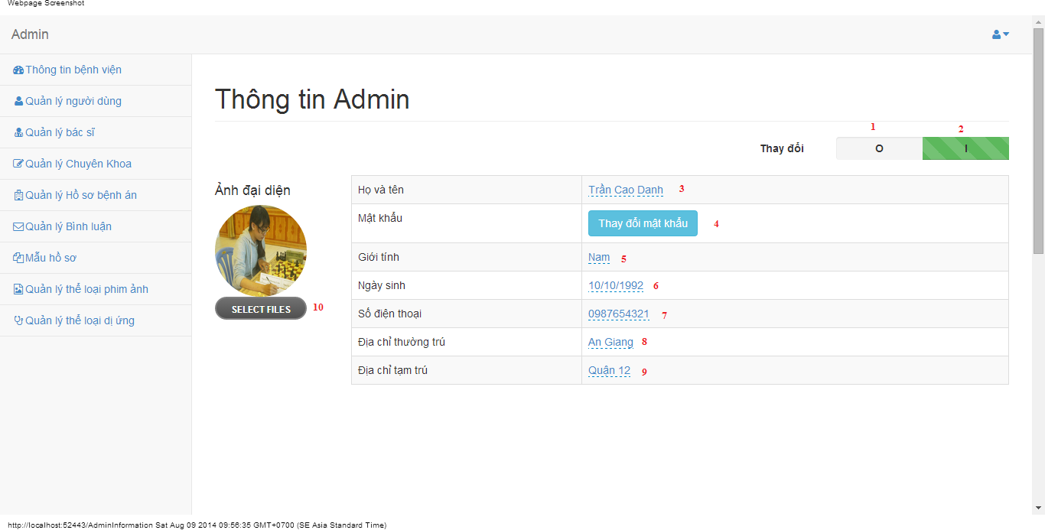

#### Objects and Actions

#### Data fields

|  |  |  |  |  |  |  |
| --- | --- | --- | --- | --- | --- | --- |
| **Field No** | **Field name** | **Type** | **Mandatory** | **Data type** | **Max length** | **Description** |
| 3 | Họ và tên | Textbox | Yes | String | 50 | Contain user’s full name |
| 5 | Giới tính | List | Yes | String | 50 | Contain user’s gender |
| 6 | Ngày sinh | Textbox | Yes | Date | 12 | Contain user’s birthday |
| 7 | Số điện thoại | Textbox | Yes | String | 12 | Contain user’s phone |
| 8 | Địa chỉ thường trú | Textbox | Yes | String | 50 | Contain user’s primary address |
| 9 | Địa chỉ tạm trú | Textbox | No | String | 50 | Contain user’s secondary address |

#### Actions

|  |  |  |  |  |  |
| --- | --- | --- | --- | --- | --- |
| **Field No** | **Field name** | **Type** | **Action** | **Description** | **Validation** |
| 1 | 0 | Checkbox | On click | Click “0” to view table admin information |  |
| 2 | I | Checkbox | On click | Click “I” to edit table data admin information |  |
| 4 | Thay đổi mật khẩu | Button | On click | Forward to popup “ChangePassword” |  |
| 10 | Chọn tệp | File | On click | Submit inputted file to server |  |

### MANAGE USERS SCREEN

#### Screen image

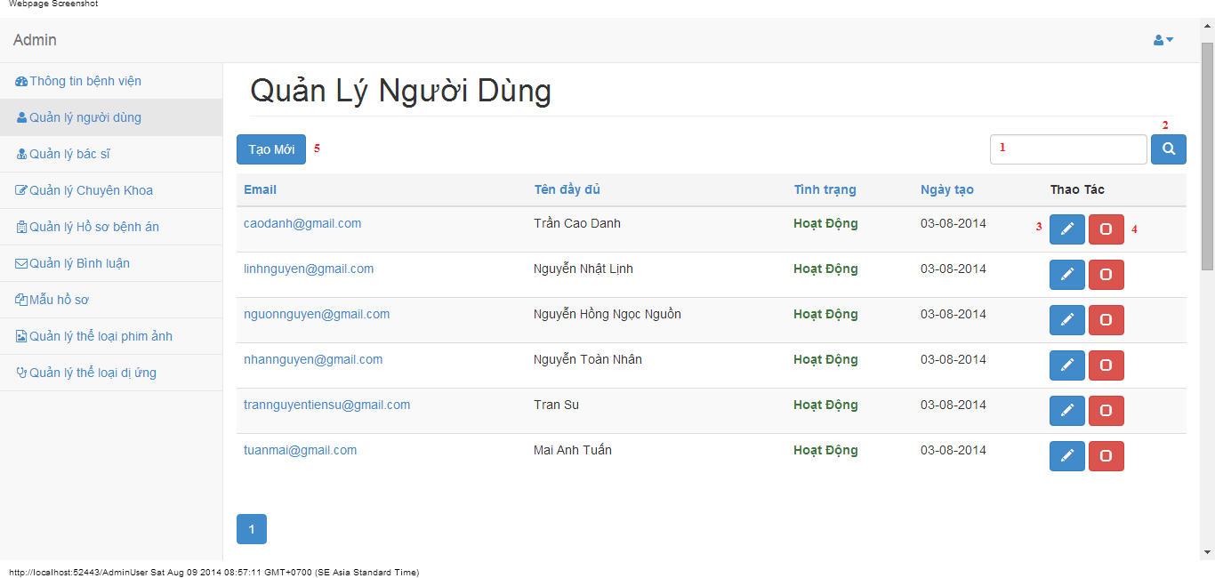

#### Objects and Actions

#### Data fields

|  |  |  |  |  |  |  |
| --- | --- | --- | --- | --- | --- | --- |
| **Field No** | **Field name** | **Type** | **Mandatory** | **Data type** | **Max length** | **Description** |
| 1 | Search | Textbox | No | String | 50 | Contain search condition to find some user account |

#### Actions

|  |  |  |  |  |  |
| --- | --- | --- | --- | --- | --- |
| **Field No** | **Field name** | **Type** | **Action** | **Description** | **Validation** |
| 2 | Tìm | Button | On click | Send inputted search condition to server |  |
| 3 | Cập nhật | Button | On click | Forward to popup “Edit” |  |
| 4 | Vô hiệu/Kích hoạt | Link | On click | Deactivate user or Activate user |  |
| 5 | Tạo mới | Button | On click | Forward to popup “Create” |  |

### CREATE USER SCREEN

#### Screen image

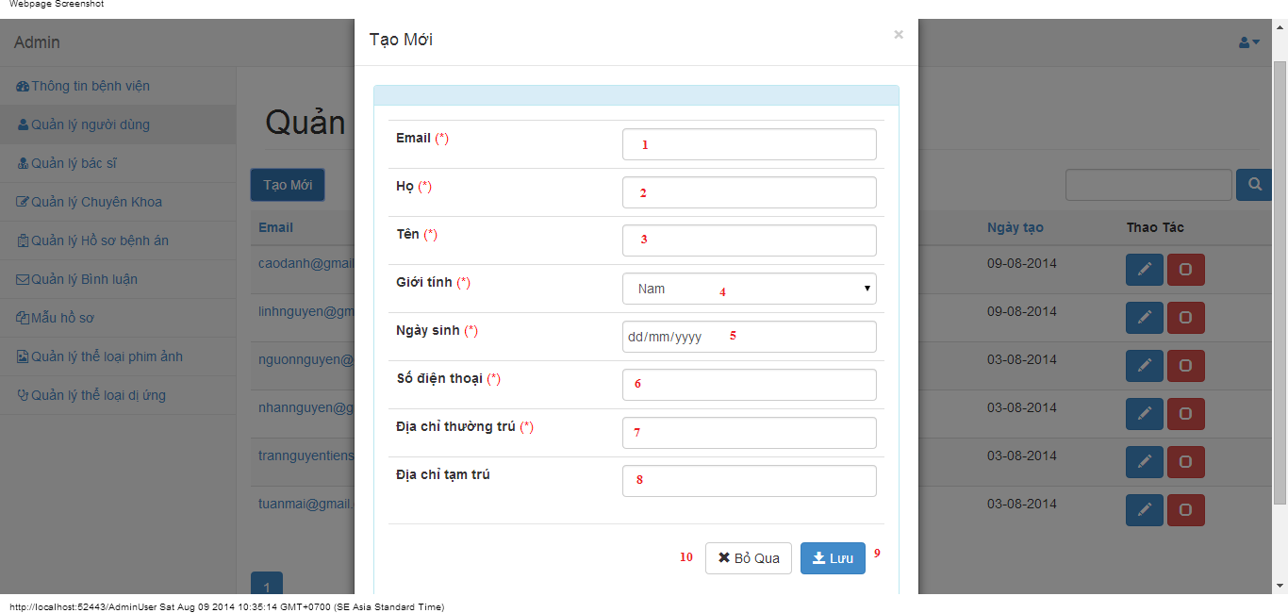

#### Objects and Actions

#### Data fields

|  |  |  |  |  |  |  |
| --- | --- | --- | --- | --- | --- | --- |
| **Field No** | **Field name** | **Type** | **Mandatory** | **Data type** | **Max length** | **Description** |
| 1 | Email | Textbox | Yes | String | 50 | Contain user’s email |
| 2 | Họ | Textbox | Yes | String | 50 | Contain user’s last name |
| 3 | Tên | Textbox | Yes | String | 50 | Contain user’s first name |
| 4 | Giới tính | Textbox | Yes | String |  | Contain user’s gender |
| 5 | Ngày sinh | Textbox | Yes | Date |  | Contain user’s birthday |
| 6 | Số điện thoại | Textbox | Yes | String | 12 | Contain user’s phone |
| 7 | Địa chỉ thường trú | Textbox | Yes | String | 50 | Contain user’s primary address |
| 8 | Địa chỉ tạm trú | Textbox | No | String | 50 | Contain user’s secondary address |

#### Actions

|  |  |  |  |  |  |
| --- | --- | --- | --- | --- | --- |
| **Field No** | **Field name** | **Type** | **Action** | **Description** | **Validation** |
| 9 | Lưu | Button | On click | Submit inputted data to server | Inputted data must be valid |
| 10 | Bỏ qua | Button | On click | Dismiss popup |  |

### EDIT USER SCREEN

#### Screen image

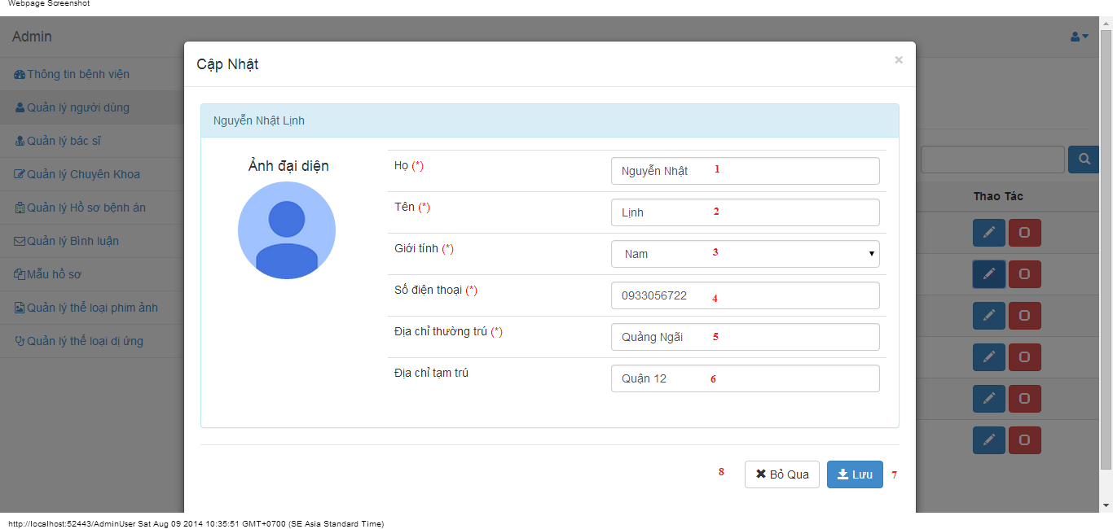

#### Objects and Actions

#### Data fields

|  |  |  |  |  |  |  |
| --- | --- | --- | --- | --- | --- | --- |
| **Field No** | **Field name** | **Type** | **Mandatory** | **Data type** | **Max length** | **Description** |
| 1 | Họ | Textbox | Yes | String | 50 | Contain user’s last name |
| 2 | Tên | Textbox | Yes | String | 50 | Contain user’s first name |
| 3 | Giới tính | Textbox | Yes | String |  | Contain user’s gender |
| 4 | Số điện thoại | Textbox | Yes | String | 12 | Contain user’s phone |
| 5 | Địa chỉ thường trú | Textbox | Yes | String | 50 | Contain user’s primary address |
| 6 | Địa chỉ tạm trú | Textbox | No | String | 50 | Contain user’s secondary address |

#### Actions

|  |  |  |  |  |  |
| --- | --- | --- | --- | --- | --- |
| **Field No** | **Field name** | **Type** | **Action** | **Description** | **Validation** |
| 7 | Lưu | Button | On click | Submit inputted data to server | Inputted data must be valid |
| 8 | Bỏ qua | Button | On click | Dismiss popup |  |

### MANAGE DOCTORS SCREEN

#### Screen image

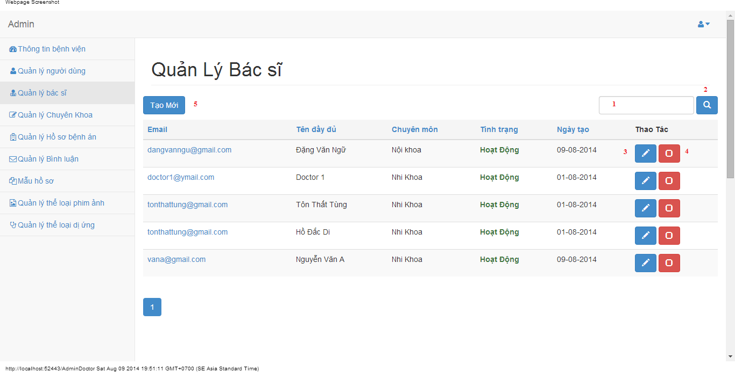

#### Objects and Actions

#### Data fields

|  |  |  |  |  |  |  |
| --- | --- | --- | --- | --- | --- | --- |
| **Field No** | **Field name** | **Type** | **Mandatory** | **Data type** | **Max length** | **Description** |
| 1 | Search | Textbox | No | String | 50 | Contain search condition to find some user account |

#### Actions

|  |  |  |  |  |  |
| --- | --- | --- | --- | --- | --- |
| **Field No** | **Field name** | **Type** | **Action** | **Description** | **Validation** |
| 2 | Tìm | Button | On click | Send inputted search condition to server |  |
| 3 | Cập nhật | Button | On click | Forward to popup “Edit” |  |
| 4 | Vô hiệu/Kích hoạt | Link | On click | Deactivate user or Activate user |  |
| 5 | Tạo mới | Button | On click | Forward to popup “Create” |  |

### CREATE DOCTOR SCREEN

#### Screen image

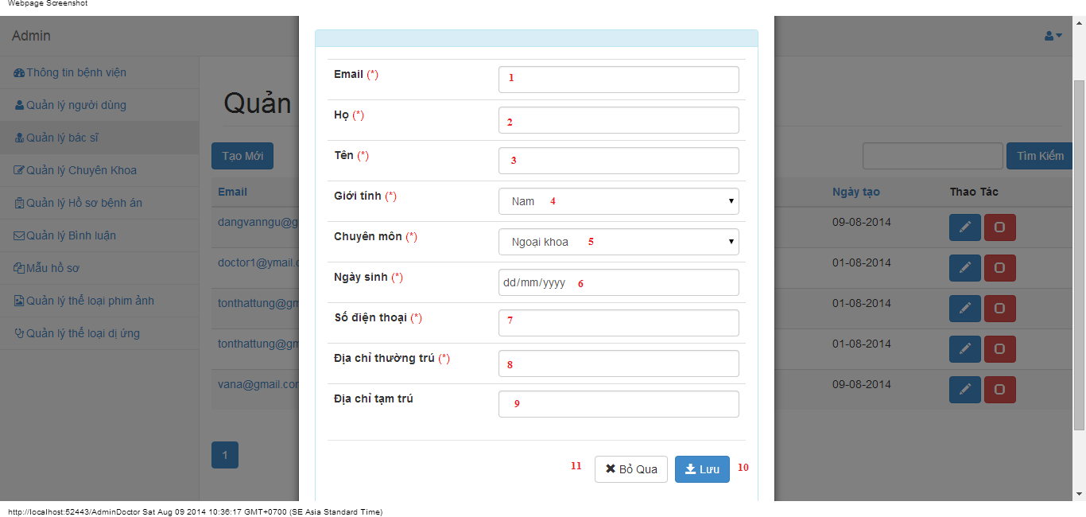

#### Objects and Actions

#### Data fields

|  |  |  |  |  |  |  |
| --- | --- | --- | --- | --- | --- | --- |
| **Field No** | **Field name** | **Type** | **Mandatory** | **Data type** | **Max length** | **Description** |
| 1 | Email | Textbox | Yes | String | 50 | Contain user’s email |
| 2 | Họ | Textbox | Yes | String | 50 | Contain user’s last name |
| 3 | Tên | Textbox | Yes | String | 50 | Contain user’s first name |
| 4 | Giới tính | Textbox | Yes | String |  | Contain user’s gender |
| 5 | Chuyên môn | DDL | Yes | String |  | Contain user’s specialty field |
| 6 | Ngày sinh | Textbox | Yes | Date |  | Contain user’s birthday |
| 7 | Số điện thoại | Textbox | Yes | String | 12 | Contain user’s phone |
| 8 | Địa chỉ thường trú | Textbox | Yes | String | 50 | Contain user’s primary address |
| 9 | Địa chỉ tạm trú | Textbox | No | String | 50 | Contain user’s secondary address |

#### Actions

|  |  |  |  |  |  |
| --- | --- | --- | --- | --- | --- |
| **Field No** | **Field name** | **Type** | **Action** | **Description** | **Validation** |
| 9 | Lưu | Button | On click | Submit inputted data to server |  |
| 10 | Bỏ qua | Button | On click | Dismiss popup |  |

### EDIT DOCTOR SCREEN

#### Screen image

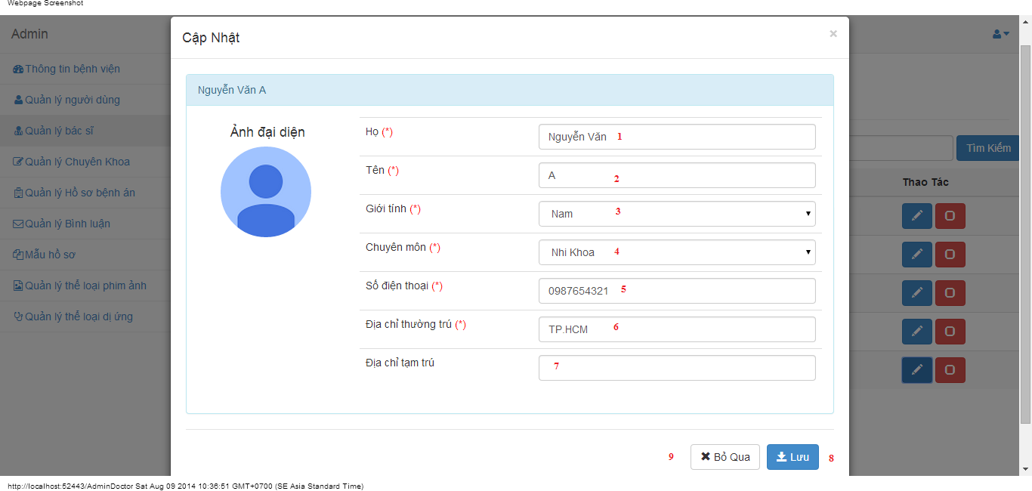

#### Objects and Actions

#### Data fields

|  |  |  |  |  |  |  |
| --- | --- | --- | --- | --- | --- | --- |
| **Field No** | **Field name** | **Type** | **Mandatory** | **Data type** | **Max length** | **Description** |
| 1 | Họ | Textbox | Yes | String | 50 | Contain user’s last name |
| 2 | Tên | Textbox | Yes | String | 50 | Contain user’s first name |
| 3 | Giới tính | Textbox | Yes | String |  | Contain user’s gender |
| 4 | Chuyên môn | DDL | Yes | String |  | Contain user’s specialty field |
| 5 | Số điện thoại | Textbox | Yes | String | 12 | Contain user’s phone |
| 6 | Địa chỉ thường trú | Textbox | Yes | String | 50 | Contain user’s primary address |
| 7 | Địa chỉ tạm trú | Textbox | No | String | 50 | Contain user’s secondary address |

#### Actions

|  |  |  |  |  |  |
| --- | --- | --- | --- | --- | --- |
| **Field No** | **Field name** | **Type** | **Action** | **Description** | **Validation** |
| 7 | Lưu | Button | On click | Submit inputted data to server | Inputted data must be valid |
| 8 | Bỏ qua | Button | On click | Dismiss popup |  |

### MANAGE SPECIALTY FIELDS SCREEN

#### Screen image

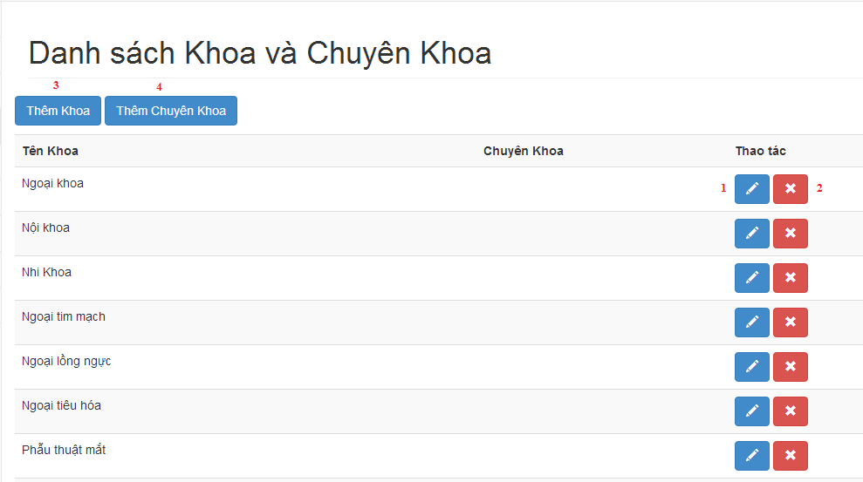

#### Objects and Actions

#### Data fields

|  |  |  |  |  |  |  |
| --- | --- | --- | --- | --- | --- | --- |
| **Field No** | **Field name** | **Type** | **Mandatory** | **Data type** | **Max length** | **Description** |

#### Actions

|  |  |  |  |  |  |
| --- | --- | --- | --- | --- | --- |
| **Field No** | **Field name** | **Type** | **Action** | **Description** | **Validation** |
| 1 | Cập nhật | Button | On click | Forward to popup “Edit” |  |
| 2 | Xóa | Button | On click | Delete a specialty field |  |
| 3 | Thêm khoa | Button | On click | Forward to popup “Create” |  |
| 4 | Thêm chuyên khoa | Button | On click | Forward to popup “Create” |  |

### CREATE SPECIALTY FIELD SCREEN

#### Screen image

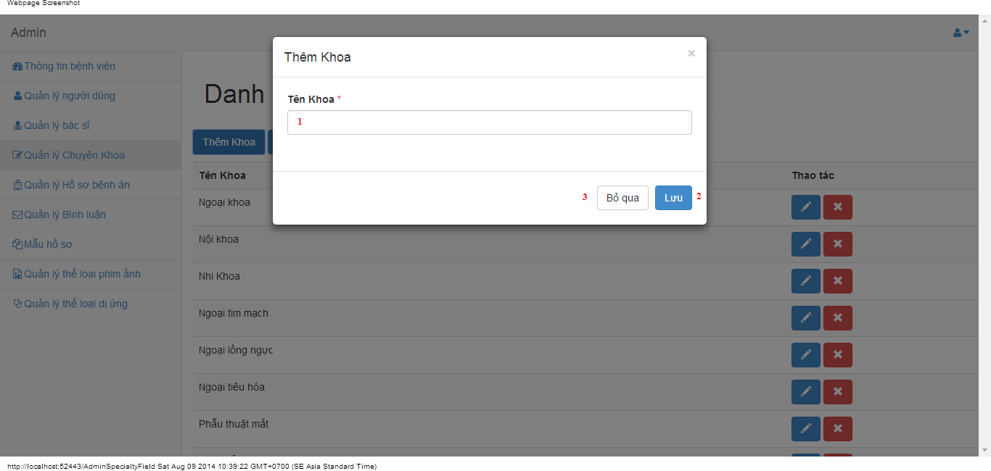

#### Objects and Actions

#### Data fields

|  |  |  |  |  |  |  |
| --- | --- | --- | --- | --- | --- | --- |
| **Field No** | **Field name** | **Type** | **Mandatory** | **Data type** | **Max length** | **Description** |
| 1 | Tên khoa | Textbox | Yes | String | 50 | Contain specialty field |

#### Actions

|  |  |  |  |  |  |
| --- | --- | --- | --- | --- | --- |
| **Field No** | **Field name** | **Type** | **Action** | **Description** | **Validation** |
| 9 | Lưu | Button | On click | Submit inputted data to server | Inputted data must be valid |
| 10 | Bỏ qua | Button | On click | Dismiss popup |  |

### CREATE SPECIALTY FIELD SCREEN

#### Screen image

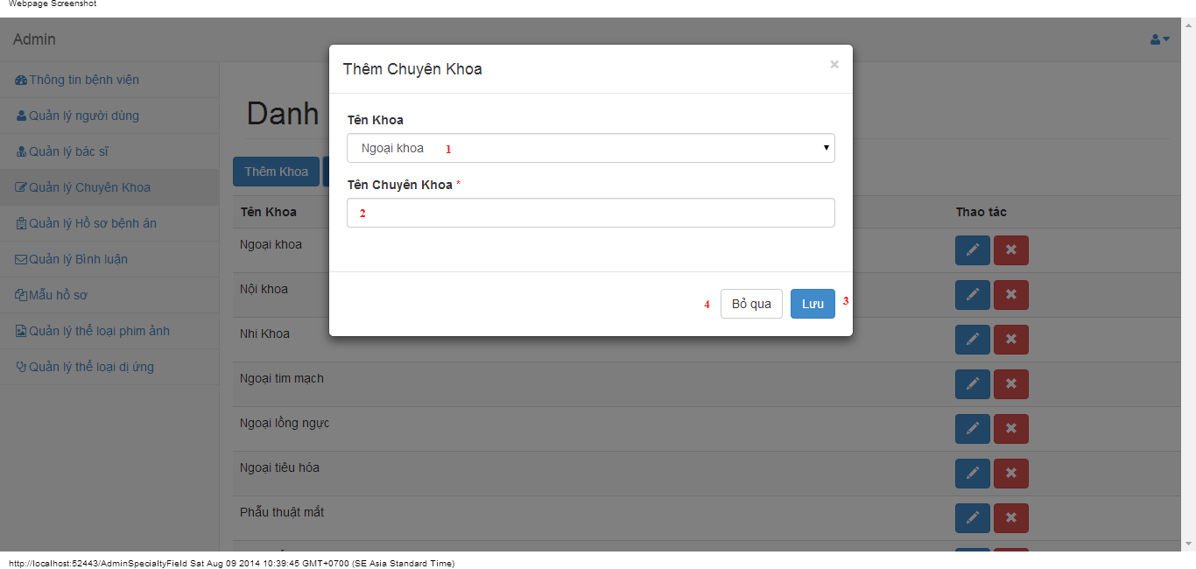

#### Objects and Actions

#### Data fields

|  |  |  |  |  |  |  |
| --- | --- | --- | --- | --- | --- | --- |
| **Field No** | **Field name** | **Type** | **Mandatory** | **Data type** | **Max length** | **Description** |
| 1 | Tên Khoa | DDL | Yes | String | 50 | Contain parent specialty fields |
| 2 | Tên Chuyên Khoa | Textbox | Yes | String | 50 | Contain specialty field |

#### Actions

|  |  |  |  |  |  |
| --- | --- | --- | --- | --- | --- |
| **Field No** | **Field name** | **Type** | **Action** | **Description** | **Validation** |
| 7 | Lưu | Button | On click | Submit inputted data to server | Inputted data must be valid |
| 8 | Bỏ qua | Button | On click | Dismiss popup |  |

### EDIT SPECIALTY FIELD SCREEN

#### Screen image

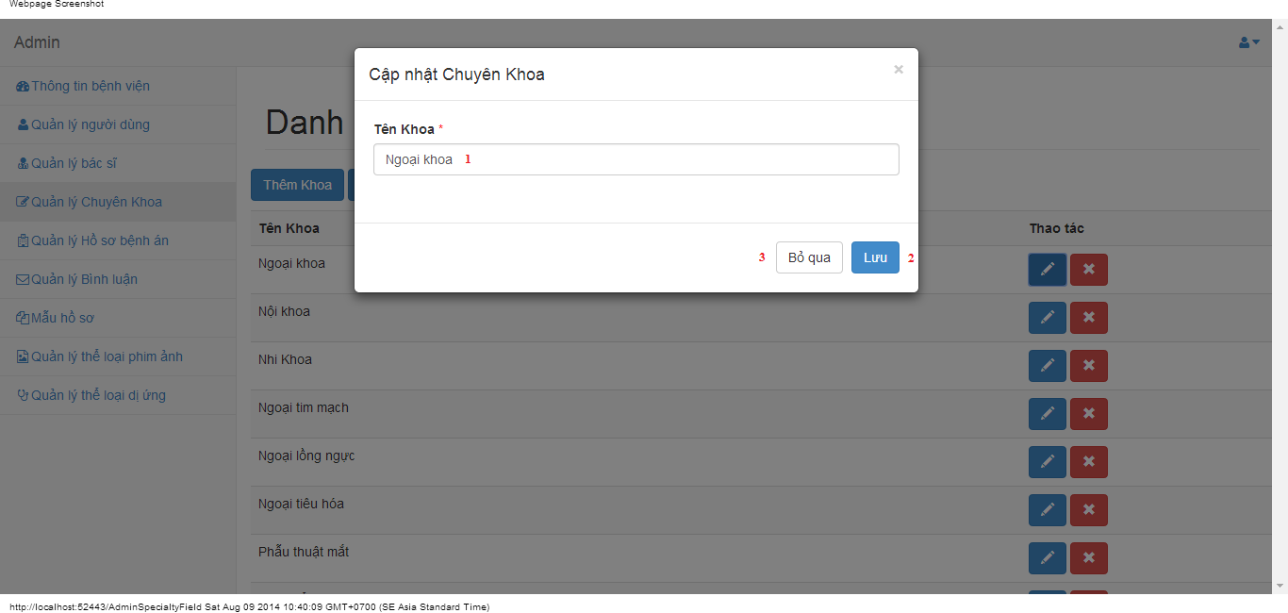

#### Objects and Actions

#### Data fields

|  |  |  |  |  |  |  |
| --- | --- | --- | --- | --- | --- | --- |
| **Field No** | **Field name** | **Type** | **Mandatory** | **Data type** | **Max length** | **Description** |
| 1 | Tên khoa | Textbox | Yes | String | 50 | Contain specialty field |

#### Actions

|  |  |  |  |  |  |
| --- | --- | --- | --- | --- | --- |
| **Field No** | **Field name** | **Type** | **Action** | **Description** | **Validation** |
| 9 | Lưu | Button | On click | Submit inputted data to server | Inputted data must be valid |
| 10 | Bỏ qua | Button | On click | Dismiss popup |  |

### EDIT SPECIALTY FIELD SCREEN

#### Screen image

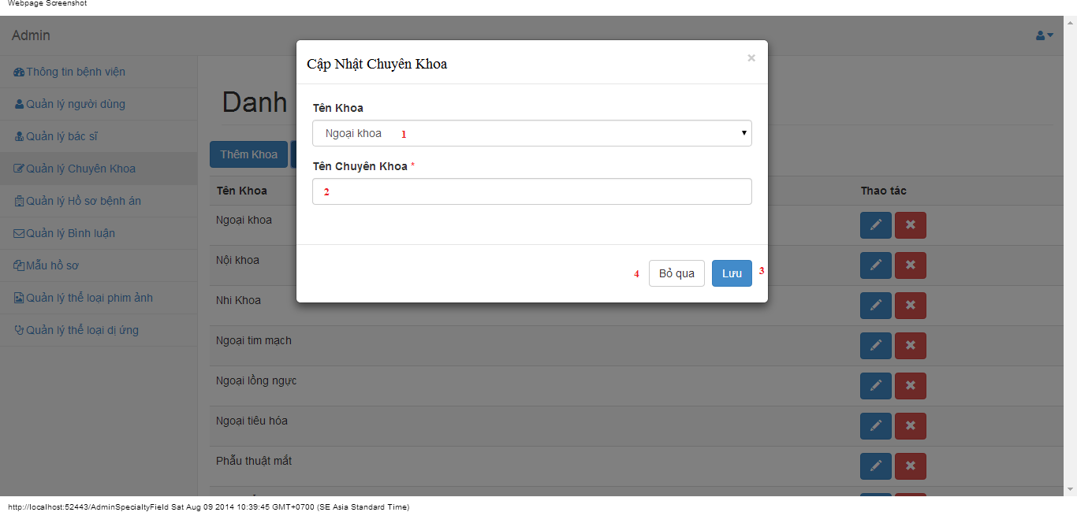

#### Objects and Actions

#### Data fields

|  |  |  |  |  |  |  |
| --- | --- | --- | --- | --- | --- | --- |
| **Field No** | **Field name** | **Type** | **Mandatory** | **Data type** | **Max length** | **Description** |
| 1 | Tên Khoa | DDL | Yes | String | 50 | Contain parent specialty fields |
| 2 | Tên Chuyên Khoa | Textbox | Yes | String | 50 | Contain specialty field |

#### Actions

|  |  |  |  |  |  |
| --- | --- | --- | --- | --- | --- |
| **Field No** | **Field name** | **Type** | **Action** | **Description** | **Validation** |
| 7 | Lưu | Button | On click | Submit inputted data to server | Inputted data must be valid |
| 8 | Bỏ qua | Button | On click | Dismiss popup |  |

### MANAGE MEDICAL PROFILES SCREEN

#### Screen image

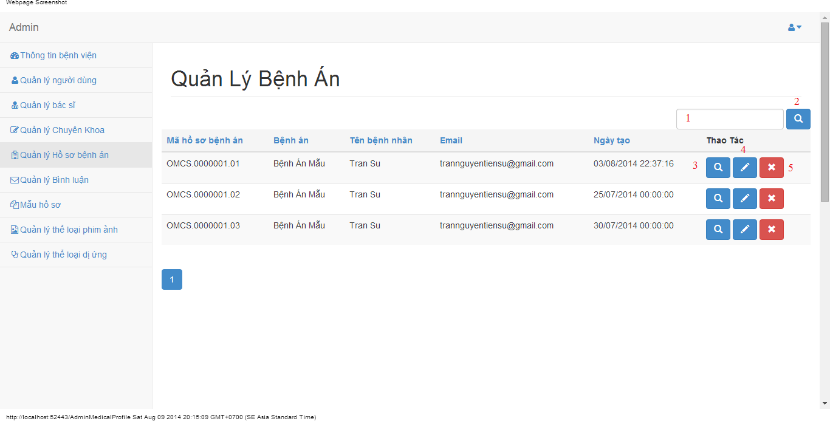

#### Objects and Actions

#### Data fields

|  |  |  |  |  |  |  |
| --- | --- | --- | --- | --- | --- | --- |
| **Field No** | **Field name** | **Type** | **Mandatory** | **Data type** | **Max length** | **Description** |
| 1 | Search | Textbox | No | String | 50 | Contain search condition to find some medical profile |

#### Actions

|  |  |  |  |  |  |
| --- | --- | --- | --- | --- | --- |
| **Field No** | **Field name** | **Type** | **Action** | **Description** | **Validation** |
| 2 | Tìm | Button | On click | Send inputted search condition to server |  |
| 3 | Xem chi tiết | Button | On click | Forward to “Details” page |  |
| 4 | Cập nhật | Link | On click | Forward to “UpdateMedicalProfile” page |  |
| 5 | Xóa | Button | On click | Delete a medical profile |  |

### VIEW MEDICAL PROFILE SCREEN

#### Screen image

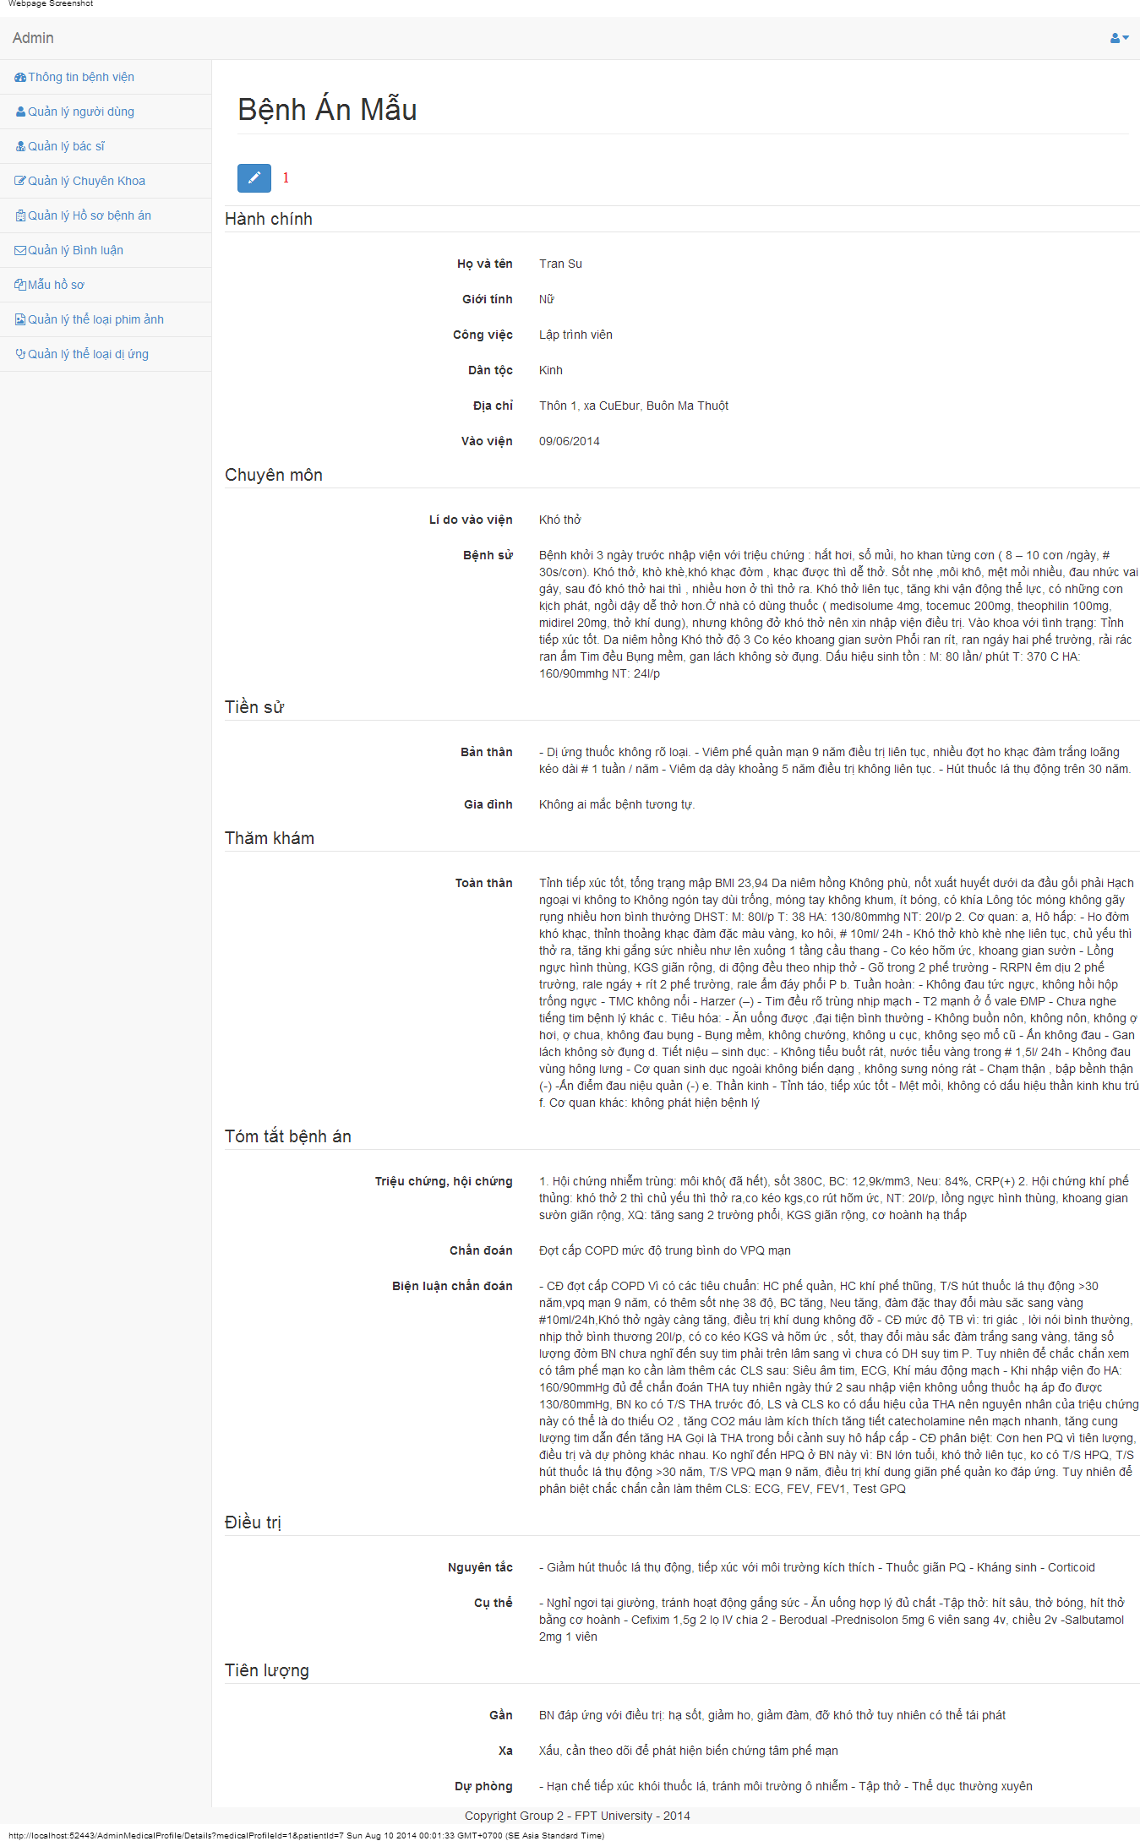

#### Objects and Actions

#### Data fields

|  |  |  |  |  |  |  |
| --- | --- | --- | --- | --- | --- | --- |
| **Field No** | **Field name** | **Type** | **Mandatory** | **Data type** | **Max length** | **Description** |

#### Actions

|  |  |  |  |  |  |
| --- | --- | --- | --- | --- | --- |
| **Field No** | **Field name** | **Type** | **Action** | **Description** | **Validation** |
| 1 | Cập nhật | Link | On click | Forward to “UpdateMedicalProfile” page |  |

### UPDATE MEDICAL PROFILE SCREEN

#### Screen image

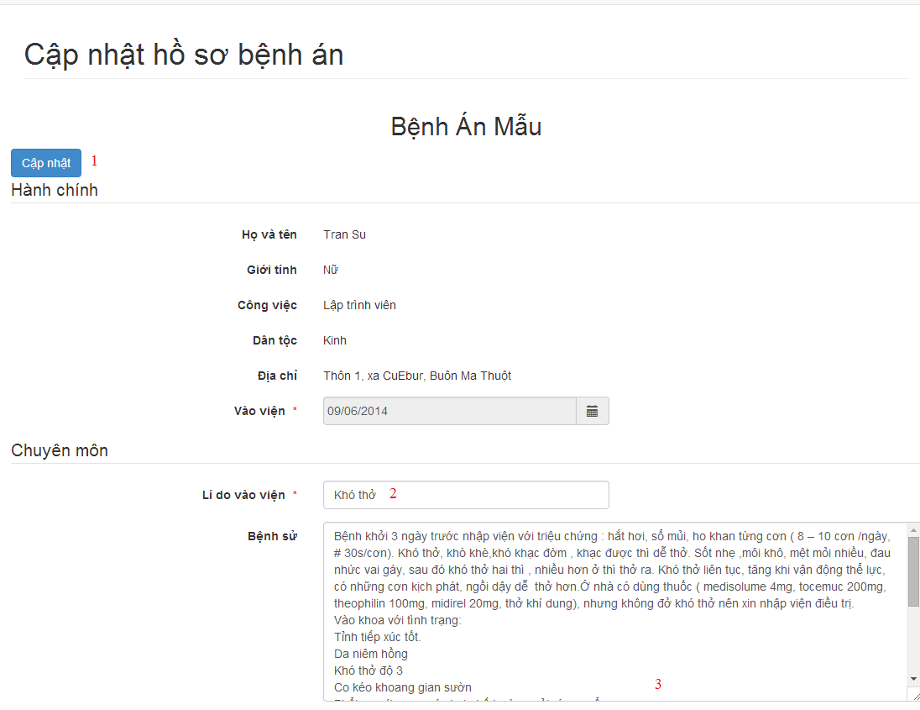

#### Objects and Actions

#### Data fields

|  |  |  |  |  |  |  |
| --- | --- | --- | --- | --- | --- | --- |
| **Field No** | **Field name** | **Type** | **Mandatory** | **Data type** | **Max length** | **Description** |
| 2 | Lí do vào viện | Textbox | Yes | String |  | Contain input follow medical profile template |
| 3 | Bệnh sử | Textbox | Yes | String |  | Contain input follow medical profile template |

#### Actions

|  |  |  |  |  |  |
| --- | --- | --- | --- | --- | --- |
| **Field No** | **Field name** | **Type** | **Action** | **Description** | **Validation** |
| 1 | Cập nhật | Link | On click | Submit inputted data to server |  |

### MANAGE MEDICAL PROFILES SCREEN

#### Screen image

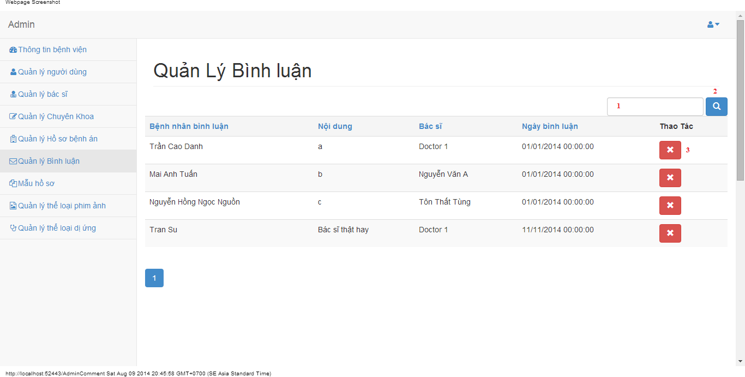

#### Objects and Actions

#### Data fields

|  |  |  |  |  |  |  |
| --- | --- | --- | --- | --- | --- | --- |
| **Field No** | **Field name** | **Type** | **Mandatory** | **Data type** | **Max length** | **Description** |
| 1 | Search | Textbox | No | String | 50 | Contain search condition to find some user account |

#### Actions

|  |  |  |  |  |  |
| --- | --- | --- | --- | --- | --- |
| **Field No** | **Field name** | **Type** | **Action** | **Description** | **Validation** |
| 2 | Tìm | Button | On click | Send inputted search condition to server |  |
| 3 | Xóa | Button | On click | Delete a comment |  |

### MANAGE MEDICAL PROFILE TEMPLATES SCREEN

#### Screen image

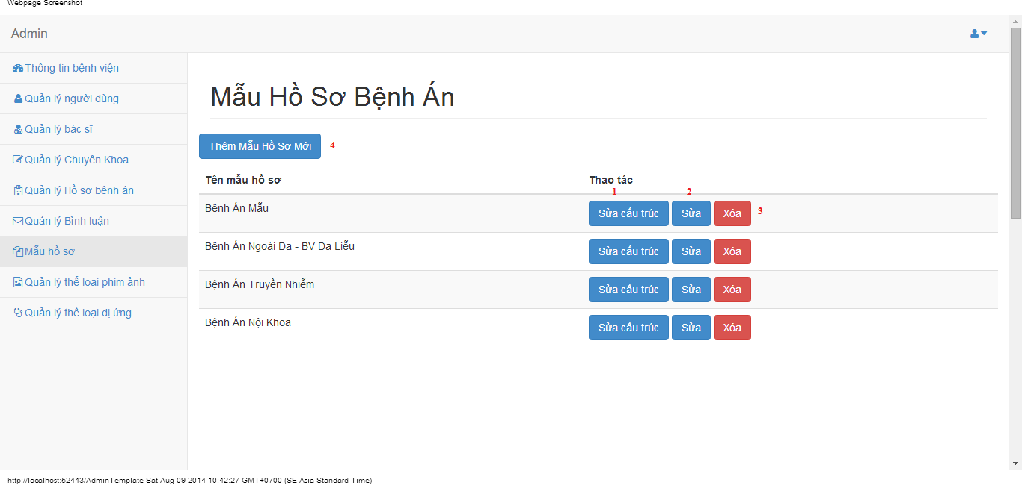

#### Objects and Actions

#### Data fields

|  |  |  |  |  |  |  |
| --- | --- | --- | --- | --- | --- | --- |
| **Field No** | **Field name** | **Type** | **Mandatory** | **Data type** | **Max length** | **Description** |

#### Actions

|  |  |  |  |  |  |
| --- | --- | --- | --- | --- | --- |
| **Field No** | **Field name** | **Type** | **Action** | **Description** | **Validation** |
| 1 | Sửa cấu trúc | Button | On click | Forward to “Editor” page |  |
| 2 | Sửa | Button | On click | Forward to popup “Edit” |  |
| 3 | Xóa | Button | On click | Delete a medical profile template |  |
| 4 | Thêm mẫu hồ sơ mới | Button | On click | Forward to popup “Create” |  |

### EDIT MEDICAL PROFILE TEMPLATES SCREEN

#### Screen image

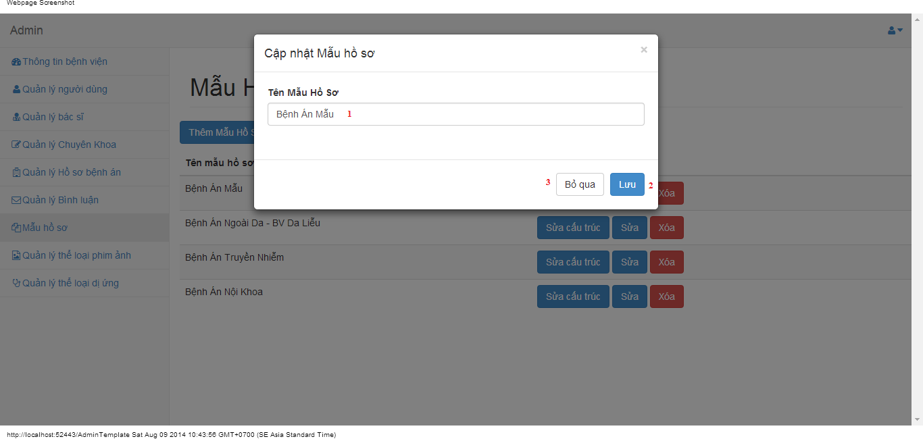

#### Objects and Actions

#### Data fields

|  |  |  |  |  |  |  |
| --- | --- | --- | --- | --- | --- | --- |
| **Field No** | **Field name** | **Type** | **Mandatory** | **Data type** | **Max length** | **Description** |
| 1 | Tên mẫu hồ sơ | Textbox | Yes | String | 50 | Contain name medical profile |

#### Actions

|  |  |  |  |  |  |
| --- | --- | --- | --- | --- | --- |
| **Field No** | **Field name** | **Type** | **Action** | **Description** | **Validation** |
| 9 | Lưu | Button | On click | Submit inputted data to server | Inputted data must be valid |
| 10 | Bỏ qua | Button | On click | Dismiss popup |  |

### ADD MEDICAL PROFILE TEMPLATES SCREEN

#### Screen image

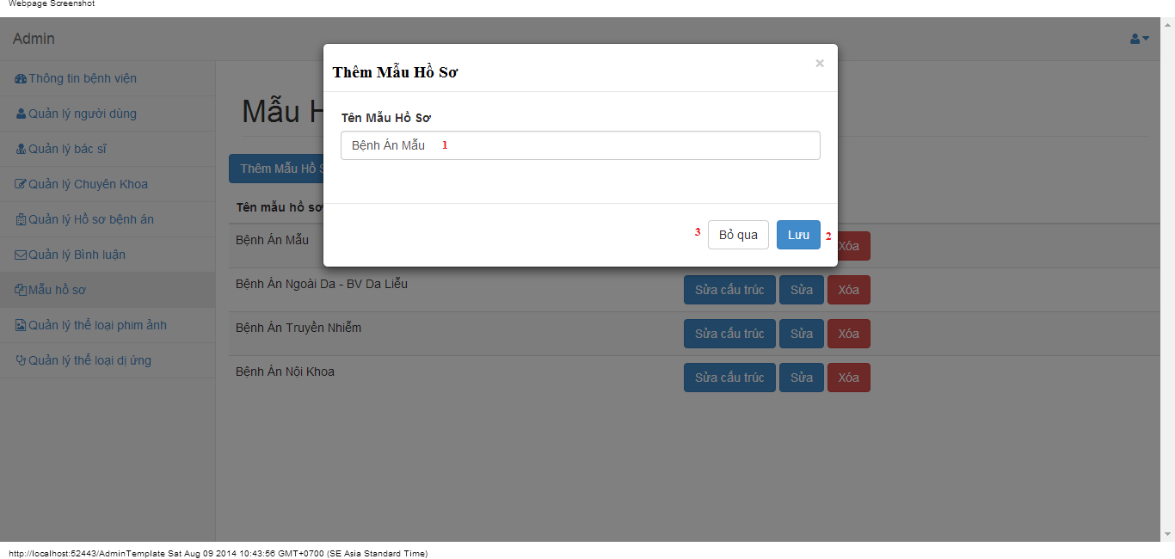

#### Objects and Actions

#### Data fields

|  |  |  |  |  |  |  |
| --- | --- | --- | --- | --- | --- | --- |
| **Field No** | **Field name** | **Type** | **Mandatory** | **Data type** | **Max length** | **Description** |
| 1 | Tên mẫu hồ sơ | Textbox | Yes | String | 50 | Contain name medical profile |

#### Actions

|  |  |  |  |  |  |
| --- | --- | --- | --- | --- | --- |
| **Field No** | **Field name** | **Type** | **Action** | **Description** | **Validation** |
| 9 | Lưu | Button | On click | Submit inputted data to server | Inputted data must be valid |
| 10 | Bỏ qua | Button | On click | Dismiss popup |  |

### EDITOR/UPDATE MEDICAL PROFILE TEMPLATES SCREEN

#### Screen image

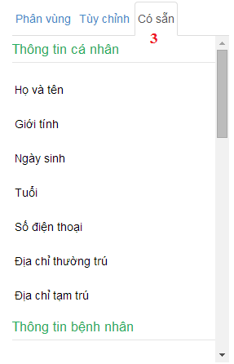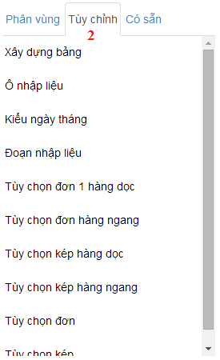 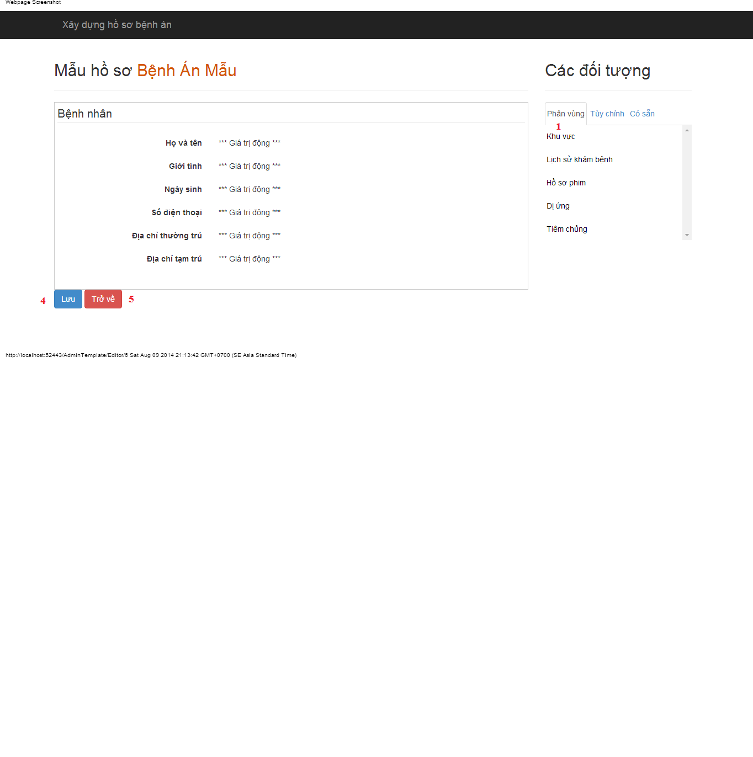

#### Objects and Actions

#### Data fields

|  |  |  |  |  |  |  |
| --- | --- | --- | --- | --- | --- | --- |
| **Field No** | **Field name** | **Type** | **Mandatory** | **Data type** | **Max length** | **Description** |

#### Actions

|  |  |  |  |  |  |
| --- | --- | --- | --- | --- | --- |
| **Field No** | **Field name** | **Type** | **Action** | **Description** | **Validation** |
| 1 | Phân vùng | Link | On click | Drag data to create/update medical profile template |  |
| 2 | Tùy chỉnh | Link | On click | Dismiss popup |  |
| 3 | Có sẵn | Link | On click | Drag data to create/update medical profile template |  |
| 4 | Lưu | Button | On click | Submit inputted data to server |  |
| 5 | Trở về | Button | On click | Back to previous page |  |

### MANAGE FILM TYPES SCREEN

#### Screen image

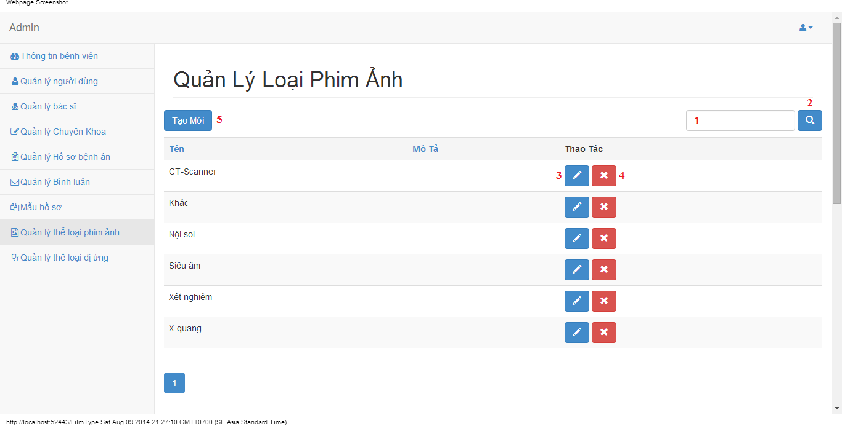

#### Objects and Actions

#### Data fields

|  |  |  |  |  |  |  |
| --- | --- | --- | --- | --- | --- | --- |
| **Field No** | **Field name** | **Type** | **Mandatory** | **Data type** | **Max length** | **Description** |
| 1 | Search | Textbox | No | String | 50 | Contain search condition to find some film type |

#### Actions

|  |  |  |  |  |  |
| --- | --- | --- | --- | --- | --- |
| **Field No** | **Field name** | **Type** | **Action** | **Description** | **Validation** |
| 2 | Tìm | Button | On click | Send inputted search condition to server |  |
| 3 | Cập nhật | Button | On click | Forward to “Edit” page |  |
| 4 | Xóa | Button | On click | Delete a film type |  |
| 5 | Tạo mới | Button | On click | Forward to “Create” page |  |

### CREATE FILM TYPE SCREEN

#### Screen image

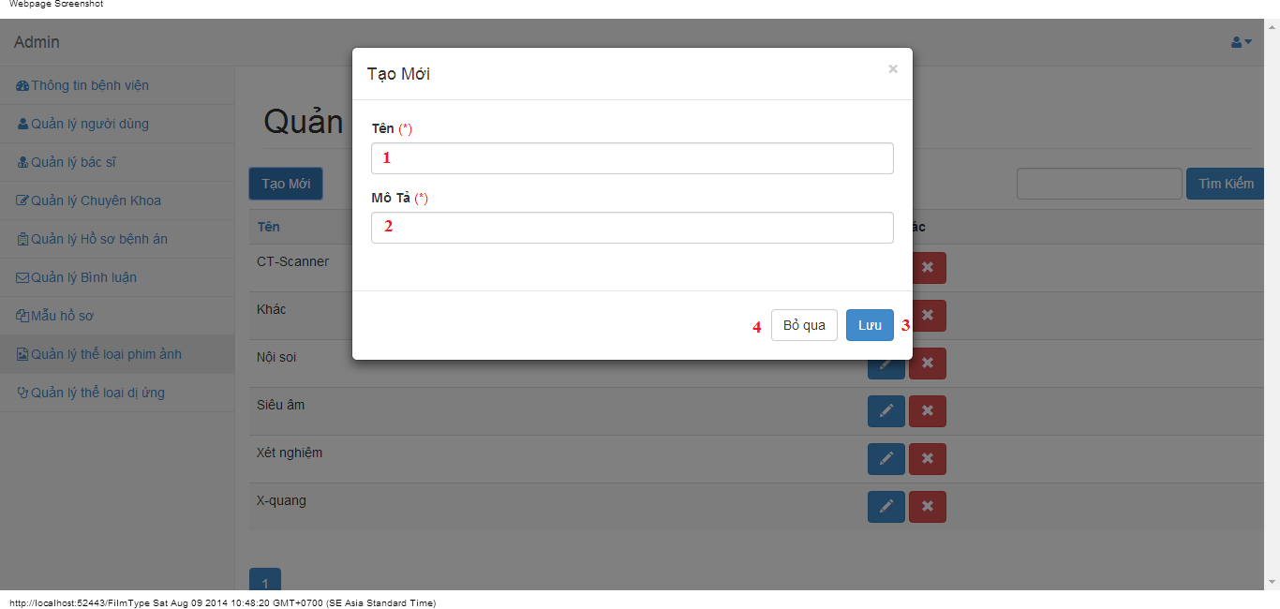

#### Objects and Actions

#### Data fields

|  |  |  |  |  |  |  |
| --- | --- | --- | --- | --- | --- | --- |
| **Field No** | **Field name** | **Type** | **Mandatory** | **Data type** | **Max length** | **Description** |
| 1 | Tên | Textbox | Yes | String | 50 | Contain film type’s name |
| 2 | Mô tả | Textbox | Yes | String | 50 | Contain film type’s description |

#### Actions

|  |  |  |  |  |  |
| --- | --- | --- | --- | --- | --- |
| **Field No** | **Field name** | **Type** | **Action** | **Description** | **Validation** |
| 9 | Lưu | Button | On click | Submit inputted data to server | Inputted data must be valid |
| 10 | Bỏ qua | Button | On click | Dismiss popup |  |

### EDIT FILM TYPE SCREEN

#### Screen image

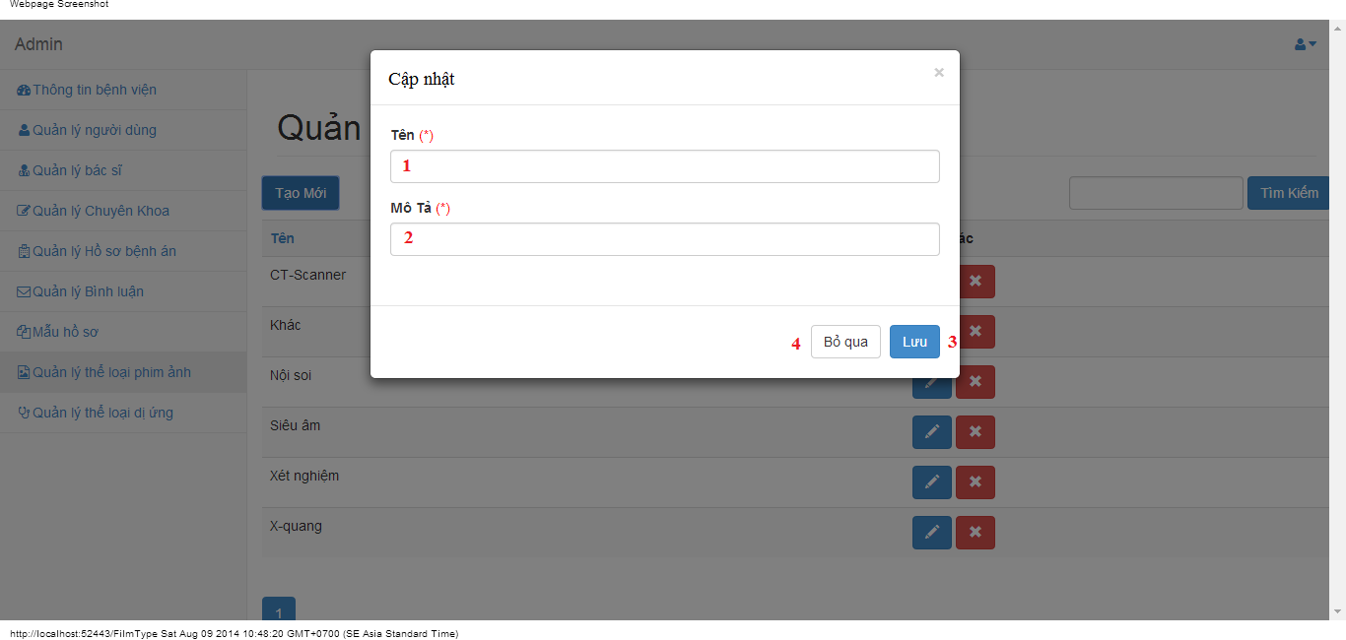

#### Objects and Actions

#### Data fields

|  |  |  |  |  |  |  |
| --- | --- | --- | --- | --- | --- | --- |
| **Field No** | **Field name** | **Type** | **Mandatory** | **Data type** | **Max length** | **Description** |
| 1 | Tên | Textbox | Yes | String | 50 | Contain film type’s name |
| 2 | Mô tả | Textbox | Yes | String | 50 | Contain film type’s description |

#### Actions

|  |  |  |  |  |  |
| --- | --- | --- | --- | --- | --- |
| **Field No** | **Field name** | **Type** | **Action** | **Description** | **Validation** |
| 9 | Lưu | Button | On click | Submit inputted data to server | Inputted data must be valid |
| 10 | Bỏ qua | Button | On click | Dismiss popup |  |

### MANAGE ALLERGY TYPES SCREEN

#### Screen image

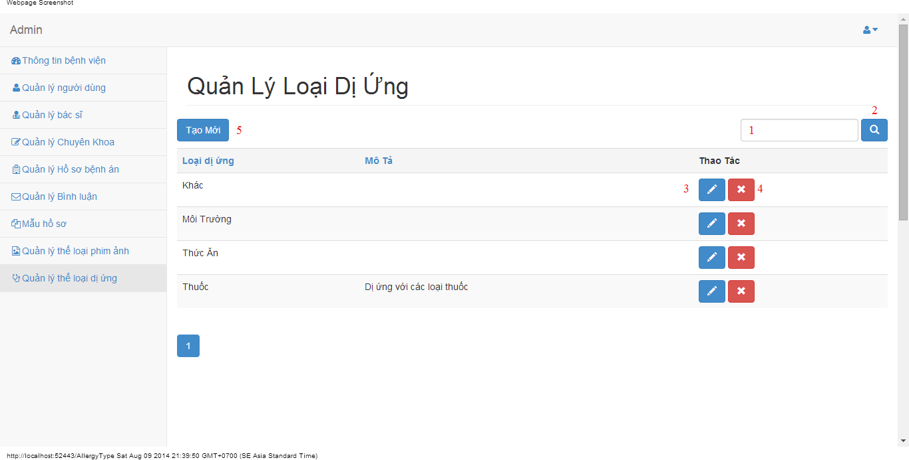

#### Objects and Actions

#### Data fields

|  |  |  |  |  |  |  |
| --- | --- | --- | --- | --- | --- | --- |
| **Field No** | **Field name** | **Type** | **Mandatory** | **Data type** | **Max length** | **Description** |
| 1 | Search | Textbox | No | String | 50 | Contain search condition to find some allergy |

#### Actions

|  |  |  |  |  |  |
| --- | --- | --- | --- | --- | --- |
| **Field No** | **Field name** | **Type** | **Action** | **Description** | **Validation** |
| 2 | Tìm | Button | On click | Send inputted search condition to server |  |
| 3 | Cập nhật | Button | On click | Forward to “Edit” page |  |
| 4 | Xóa | Button | On click | Delete an allergy type |  |
| 5 | Tạo mới | Button | On click | Forward to “Create” page |  |

### CREATE ALLERGY TYPE SCREEN

#### Screen image

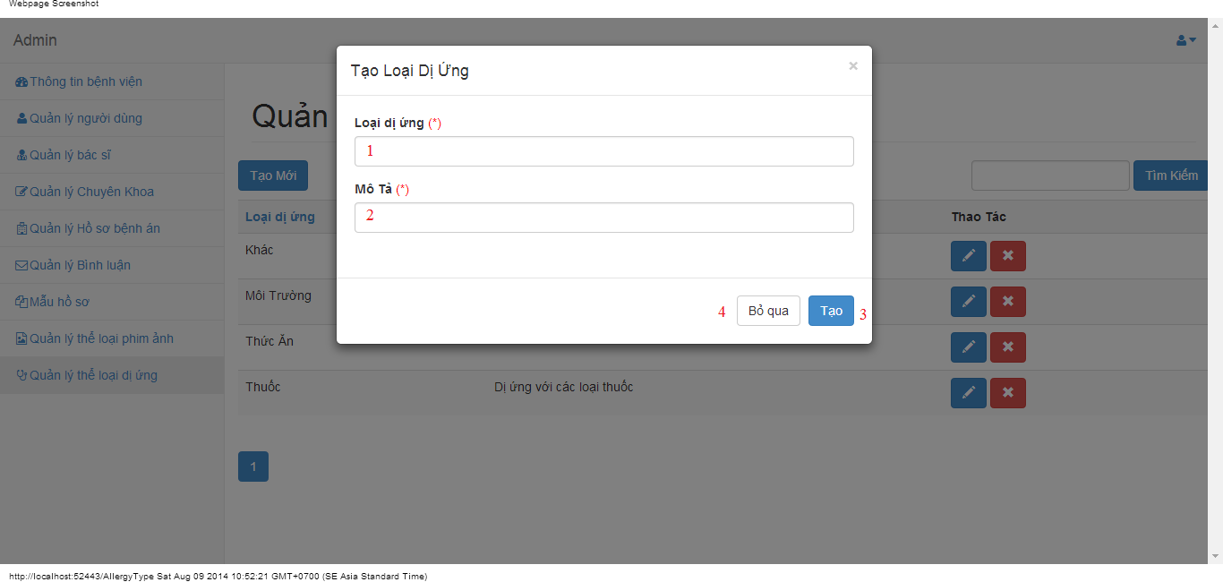

#### Objects and Actions

#### Data fields

|  |  |  |  |  |  |  |
| --- | --- | --- | --- | --- | --- | --- |
| **Field No** | **Field name** | **Type** | **Mandatory** | **Data type** | **Max length** | **Description** |
| 1 | Loại dị ứng | Textbox | Yes | String | 50 | Contain allergy type’s name |
| 2 | Mô tả | Textbox | Yes | String | 50 | Contain allergy type’s description |

#### Actions

|  |  |  |  |  |  |
| --- | --- | --- | --- | --- | --- |
| **Field No** | **Field name** | **Type** | **Action** | **Description** | **Validation** |
| 9 | Lưu | Button | On click | Submit inputted data to server | Inputted data must be valid |
| 10 | Bỏ qua | Button | On click | Dismiss popup |  |

### EDIT ALLERGY TYPE SCREEN

#### Screen image

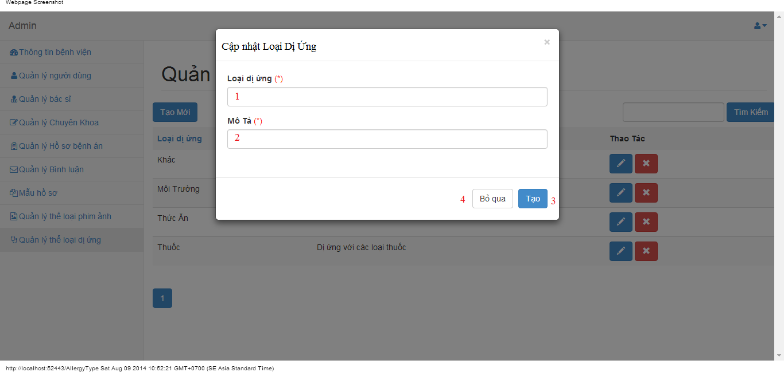

#### Objects and Actions

#### Data fields

|  |  |  |  |  |  |  |
| --- | --- | --- | --- | --- | --- | --- |
| **Field No** | **Field name** | **Type** | **Mandatory** | **Data type** | **Max length** | **Description** |
| 1 | Loại dị ứng | Textbox | Yes | String | 50 | Contain allergy type’s name |
| 2 | Mô tả | Textbox | Yes | String | 50 | Contain allergy type’s description |

#### Actions

|  |  |  |  |  |  |
| --- | --- | --- | --- | --- | --- |
| **Field No** | **Field name** | **Type** | **Action** | **Description** | **Validation** |
| 9 | Lưu | Button | On click | Submit inputted data to server | Inputted data must be valid |
| 10 | Bỏ qua | Button | On click | Dismiss popup |  |

### CHANGE PASSWORD SCREEN

#### Screen image



#### Objects and Actions

#### Data fields

|  |  |  |  |  |  |  |
| --- | --- | --- | --- | --- | --- | --- |
| **Field No** | **Field name** | **Type** | **Mandatory** | **Data type** | **Max length** | **Description** |
| 1 | Mật khẩu hiện tại | Textbox | Yes | String | 50 | Contain user’s password |
| 2 | Mật khẩu mới | Textbox | Yes | String | 50 | Contain user’s new password |
| 3 | Xác nhận mật khẩu | Textbox | Yes | String | 50 | Contain user’s re-password |

#### Actions

|  |  |  |  |  |  |
| --- | --- | --- | --- | --- | --- |
| **Field No** | **Field name** | **Type** | **Action** | **Description** | **Validation** |
| 9 | Cập nhật mật khẩu | Button | On click | Submit inputted data to server | Inputted data must be valid |
| 10 | Bỏ qua | Button | On click | Dismiss popup |  |

### MANAGE PATIENT SCREEN

#### Screen image

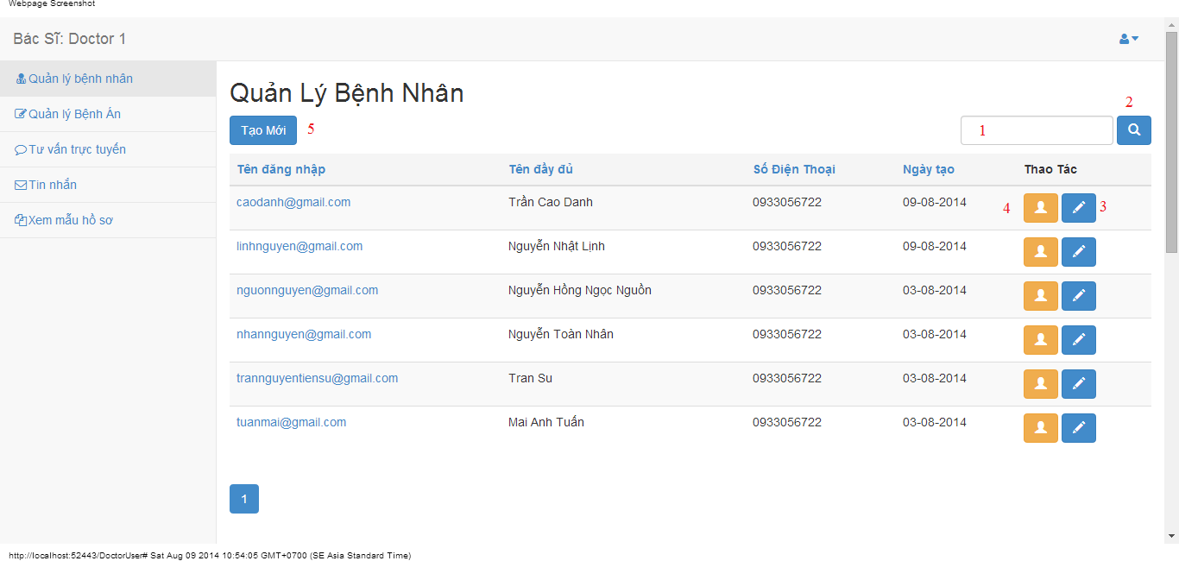

#### Objects and Actions

#### Data fields

|  |  |  |  |  |  |  |
| --- | --- | --- | --- | --- | --- | --- |
| **Field No** | **Field name** | **Type** | **Mandatory** | **Data type** | **Max length** | **Description** |
| 1 | Search | Textbox | No | String | 50 | Contain search condition to find some user account |

#### Actions

|  |  |  |  |  |  |
| --- | --- | --- | --- | --- | --- |
| **Field No** | **Field name** | **Type** | **Action** | **Description** | **Validation** |
| 2 | Tìm | Button | On click | Send inputted search condition to server |  |
| 3 | Cập nhật | Button | On click | Forward to popup “Edit” |  |
| 4 | Xem chi tiết | Link | On click | Forward to popup “View” |  |
| 5 | Tạo mới | Button | On click | Forward to popup “Create” |  |

### CREATE/EDIT PATIENT SCREEN

#### Screen image

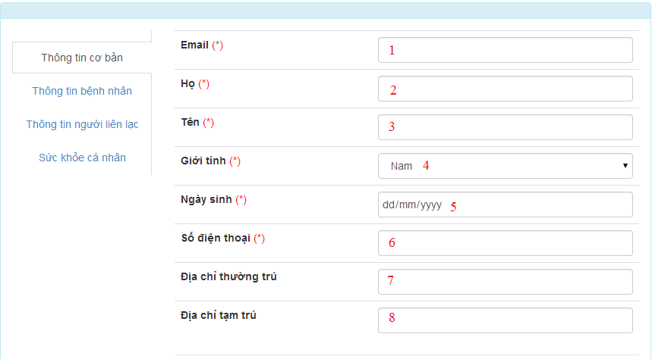









#### Objects and Actions

#### Data fields

|  |  |  |  |  |  |  |
| --- | --- | --- | --- | --- | --- | --- |
| **Field No** | **Field name** | **Type** | **Mandatory** | **Data type** | **Max length** | **Description** |
| 1 | Email | Textbox | Yes | String | 50 | Contain user’s email |
| 2 | Họ | Textbox | Yes | String | 50 | Contain user’s last name |
| 3 | Tên | Textbox | Yes | String | 50 | Contain user’s first name |
| 4 | Giới tính | Textbox | Yes | String |  | Contain user’s gender |
| 5 | Ngày sinh | Textbox | Yes | Date |  | Contain user’s birthday |
| 6 | Số điện thoại | Textbox | Yes | String | 12 | Contain user’s phone |
| 7 | Địa chỉ thường trú | Textbox | Yes | String | 50 | Contain user’s primary address |
| 8 | Địa chỉ tạm trú | Textbox | No | String | 50 | Contain user’s secondary address |
| 9 | Dân tộc | DDL | No | String | 50 | Contain user’s ethnicity |
| 10 | Quốc tịch | DDL | No | String | 50 | Contain user’s nationality |
| 11 | Công việc | Textbox | No | String | 50 | Contain user’s job |
| 12 | Nơi làm việc | Textbox | No | String | 50 | Contain user’s where to work |
| 13 | Mã số thẻ bảo hiểm y tế | Textbox | No | String | 50 | Contain user’s health insurance id |
| 14 | Ngày cấp | Textbox | No | Date | 50 | Contain user’s health insurance issued |
| 15 | Ngày hết hạn | Textbox | No | Date | 50 | Contain user’s health insurance date expired |
| 16 | Người liên lạc | Textbox | No | String | 50 | Contain user’s contact person |
| 17 | Địa chỉ người liện lạc | Textbox | No | String | 50 | Contain user’s contact person address |
| 18 | Số điện thoại người liên lạc | Textbox | No | String | 50 | Contain user’s contact person phone |
| 19 | Chiều cao | Textbox | No | String | 50 | Contain user’s height |
| 20 | Cân nặng | Textbox | No | String | 50 | Contain user’s weight |
| 21 | Màu mắt | Textbox | No | String | 50 | Contain user’s eye color |
| 22 | Màu tóc | Textbox | No | String | 50 | Contain user’s hair color |
| 23 | Nhóm máu | Textbox | No | String | 50 | Contain user’s blood type |
| 24 | Lượng đồ uống có cồn hàng tuần | Textbox | No | String | 50 | Contain user’s alcohol per week |
| 25 | Số năm uống | Textbox | No | String | 50 | Contain user’s alcohol number of year |
| 26 | Lượng thuốc hút hàng tuần | Textbox | No | String | 50 | Contain user’s smoke per week |
| 27 | Số năm hút | Textbox | No | String | 50 | Contain user’s smoke number of year |
| 28 | Tên loại thể thao | Textbox | No | String | 50 | Contain user’s sport name |
| 29 | Thời lượng tham gia hằng tuần | Textbox | No | String | 50 | Contain user’s sport per week |
| 30 | Tham gia khác | Textbox | No | String | 50 | Contain user’s exercise type |
| 31 | Thời lượng tham gia hằng tuần | Textbox | No | String | 50 | Contain user’s exercise per week |

#### Actions

|  |  |  |  |  |  |
| --- | --- | --- | --- | --- | --- |
| **Field No** | **Field name** | **Type** | **Action** | **Description** | **Validation** |
| 32 | Lưu | Button | On click | Submit inputted data to server | Inputted data must be valid |
| 33 | Bỏ qua | Button | On click | Dismiss model |  |

### VIEW PATIENT SCREEN

#### Screen image

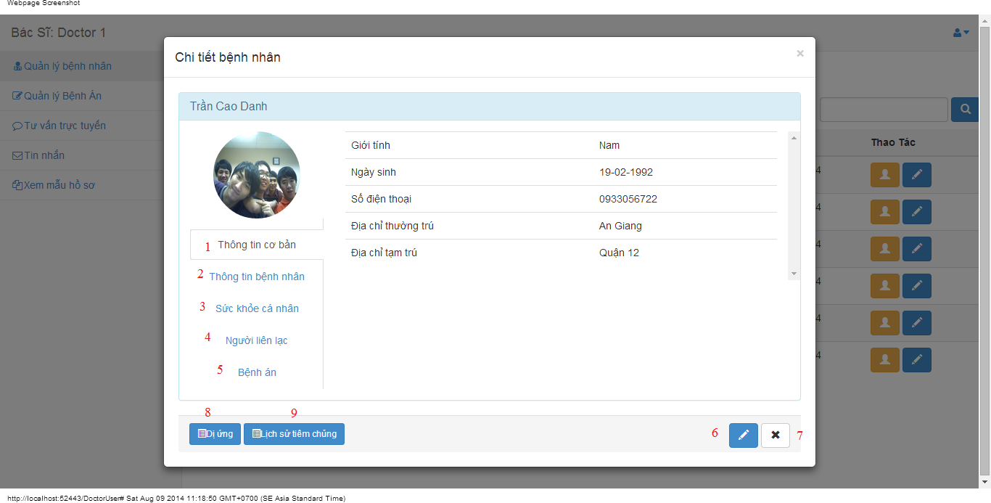

#### Objects and Actions

#### Data fields

|  |  |  |  |  |  |  |
| --- | --- | --- | --- | --- | --- | --- |
| **Field No** | **Field name** | **Type** | **Mandatory** | **Data type** | **Max length** | **Description** |

#### Actions

|  |  |  |  |  |  |
| --- | --- | --- | --- | --- | --- |
| **Field No** | **Field name** | **Type** | **Action** | **Description** | **Validation** |
| 1 | Thông tin cơ bản | Link | On click | Contain user’s basic information. |  |
| 2 | Thông tin bệnh nhân | Link | On click | Contain patient’s information. |  |
| 3 | Sức khỏe cá nhân | Link | On click | Contain user’s health record |  |
| 4 | Người liên lạc | Link | On click | Contain user’s contact person information |  |
| 5 | Bệnh án | Link | On click | Add/Edit medical profile for patient |  |
| 6 | Cập nhật | Button | On click | Forward to popup “EditPatient” |  |
| 7 | Bỏ qua | Button | On click | Dismiss modal |  |
| 8 | Dị ứng | Button | On click | Forward to popup “Allergy” |  |
| 9 | Lịch sử tiêm chủng | Button | On click | Forward to popup “Immunization” |  |

### DOCTOR COMMENT SCREEN

#### Screen image

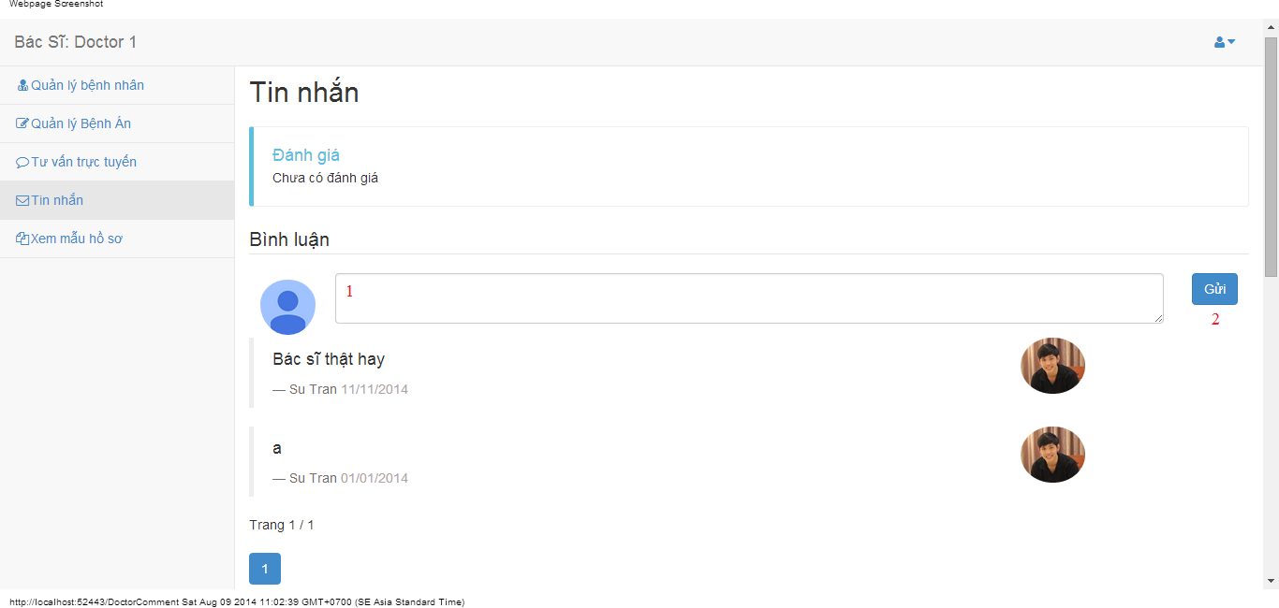

#### Objects and Actions

#### Data fields

|  |  |  |  |  |  |  |
| --- | --- | --- | --- | --- | --- | --- |
| **Field No** | **Field name** | **Type** | **Mandatory** | **Data type** | **Max length** | **Description** |
| 1 | Bình luận | Textbox | No | String |  | Comment of doctor |

#### Actions

|  |  |  |  |  |  |
| --- | --- | --- | --- | --- | --- |
| **Field No** | **Field name** | **Type** | **Action** | **Description** | **Validation** |
| 2 | Gửi | Button | On click | Summit inputted data to server |  |

### DOCTOR CONVERSATION SCREEN

#### Screen image

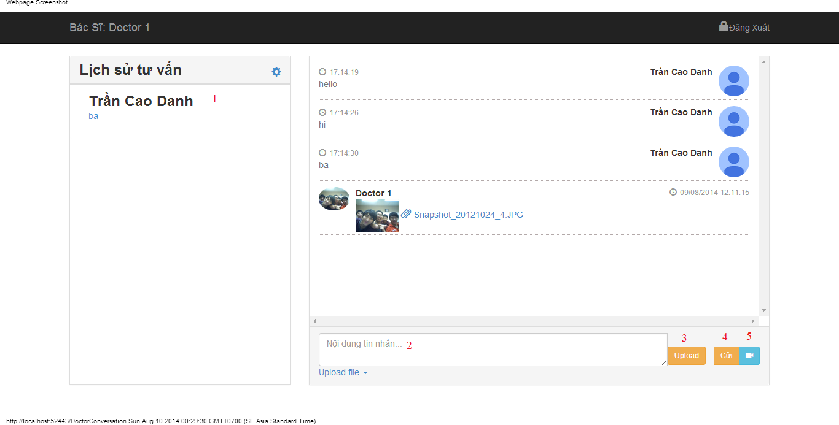

#### Objects and Actions

#### Data fields

|  |  |  |  |  |  |  |
| --- | --- | --- | --- | --- | --- | --- |
| **Field No** | **Field name** | **Type** | **Mandatory** | **Data type** | **Max length** | **Description** |
| 2 | Nội dung tin nhắn | Textbox | No | String |  | Contain user’s content conversation |

#### Actions

|  |  |  |  |  |  |
| --- | --- | --- | --- | --- | --- |
| **Field No** | **Field name** | **Type** | **Action** | **Description** | **Validation** |
| 1 | Lịch sử tư vấn | Link | On click | Click on a patient to chat |  |
| 3 | Upload | File | On click | Submit inputted file to server |  |
| 4 | Gửi | Button | On click | Submit inputted data to server |  |
| 5 | Yêu cầu xem webcam | Button | On click | Request webcam to patient |  |

### DOCTOR INFORMATION SCREEN

#### Screen image

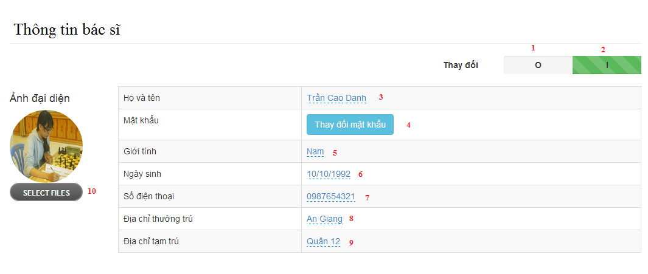

#### Objects and Actions

#### Data fields

|  |  |  |  |  |  |  |
| --- | --- | --- | --- | --- | --- | --- |
| **Field No** | **Field name** | **Type** | **Mandatory** | **Data type** | **Max length** | **Description** |
| 3 | Họ và tên | Textbox | Yes | String | 50 | Contain user’s full name |
| 5 | Giới tính | List | Yes | String | 50 | Contain user’s gender |
| 6 | Ngày sinh | Textbox | Yes | Date | 12 | Contain user’s birthday |
| 7 | Số điện thoại | Textbox | Yes | String | 12 | Contain user’s phone |
| 8 | Địa chỉ thường trú | Textbox | Yes | String | 50 | Contain user’s primary address |
| 9 | Địa chỉ tạm trú | Textbox | No | String | 50 | Contain user’s secondary address |

#### Actions

|  |  |  |  |  |  |
| --- | --- | --- | --- | --- | --- |
| **Field No** | **Field name** | **Type** | **Action** | **Description** | **Validation** |
| 1 | 0 | Checkbox | On click | Click “0” to view table admin information |  |
| 2 | I | Checkbox | On click | Click “I” to edit table data admin information |  |
| 4 | Thay đổi mật khẩu | Button | On click | Forward to popup “ChangePassword” |  |
| 10 | Chọn tệp | File | On click | Submit inputted file to server |  |

### PATIENT INFORMATION SCREEN

#### Screen image

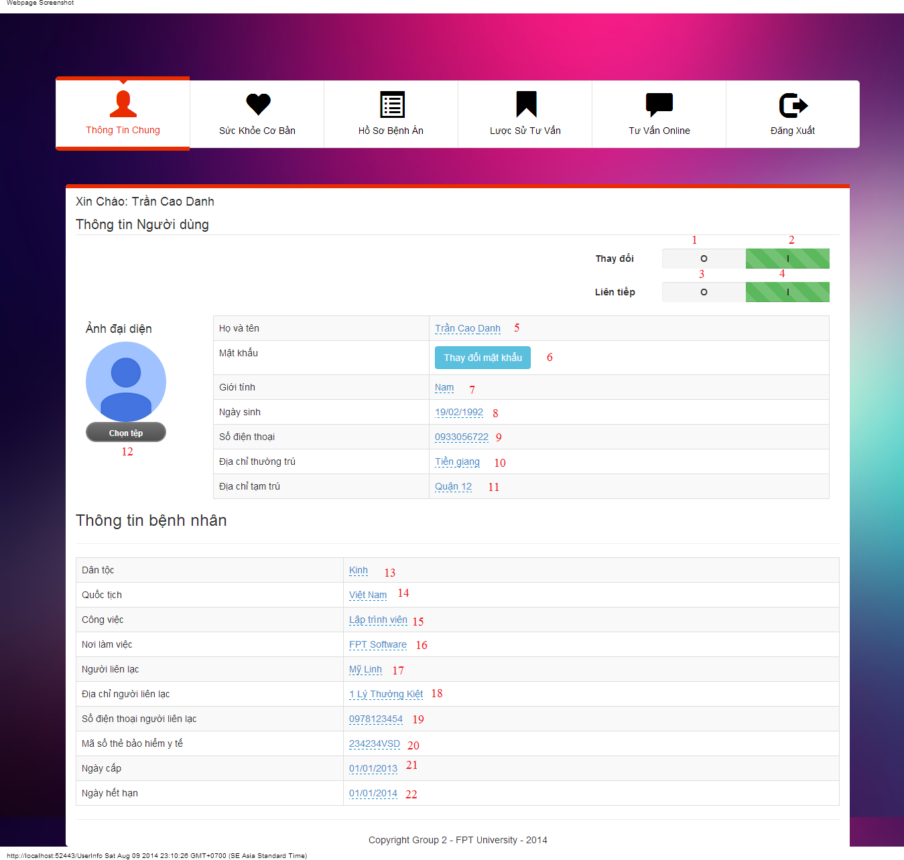

#### Objects and Actions

#### Data fields

|  |  |  |  |  |  |  |
| --- | --- | --- | --- | --- | --- | --- |
| **Field No** | **Field name** | **Type** | **Mandatory** | **Data type** | **Max length** | **Description** |
| 5 | Họ Tên | Textbox | Yes | String | 50 | Contain user’s full name |
| 7 | Giới tính | Textbox | Yes | String |  | Contain user’s gender |
| 8 | Ngày sinh | Textbox | Yes | Date |  | Contain user’s birthday |
| 9 | Số điện thoại | Textbox | Yes | String | 12 | Contain user’s phone |
| 10 | Địa chỉ thường trú | Textbox | Yes | String | 50 | Contain user’s primary address |
| 11 | Địa chỉ tạm trú | Textbox | No | String | 50 | Contain user’s secondary address |
| 12 | Dân tộc | DDL | No | String | 50 | Contain user’s ethnicity |
| 13 | Quốc tịch | DDL | No | String | 50 | Contain user’s nationality |
| 14 | Công việc | Textbox | No | String | 50 | Contain user’s job |
| 15 | Nơi làm việc | Textbox | No | String | 50 | Contain user’s where to work |
| 20 | Mã số thẻ bảo hiểm y tế | Textbox | No | String | 50 | Contain user’s health insurance id |
| 21 | Ngày cấp | Textbox | No | Date | 50 | Contain user’s health insurance issued |
| 22 | Ngày hết hạn | Textbox | No | Date | 50 | Contain user’s health insurance date expired |
| 18 | Người liên lạc | Textbox | No | String | 50 | Contain user’s contact person |
| 19 | Địa chỉ người liện lạc | Textbox | No | String | 50 | Contain user’s contact person address |
| 20 | Số điện thoại người liên lạc | Textbox | No | String | 50 | Contain user’s contact person phone |

#### Actions

|  |  |  |  |  |  |
| --- | --- | --- | --- | --- | --- |
| **Field No** | **Field name** | **Type** | **Action** | **Description** | **Validation** |
| 1 | 0 | Checkbox | On click | Click “0” to view table admin information |  |
| 2 | I | Checkbox | On click | Click “I” to edit table data admin information |  |
| 3 | O | Checkbox | On click | Click “0” to not next value after 300 second |  |
| 4 | I | Checkbox | On click | Click “0” to next value after 300 second |  |
| 6 | Thay đổi mật khẩu | Button | On click | Forward to popup “ChangePassword” |  |
| 12 | Chọn tệp | File | On click | Submit inputted file to server |  |

### PATIENT HEALTH RECORD SCREEN

#### Screen image

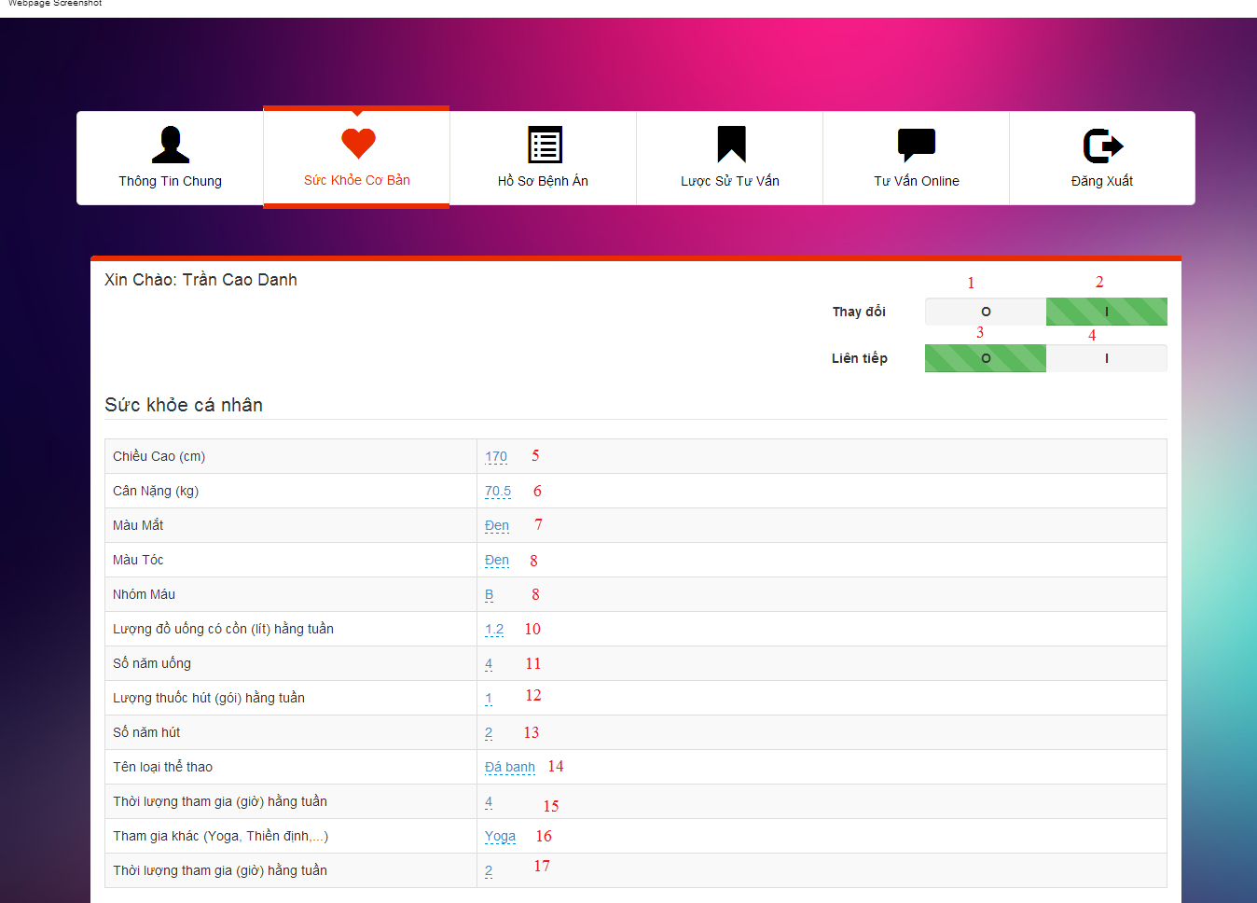

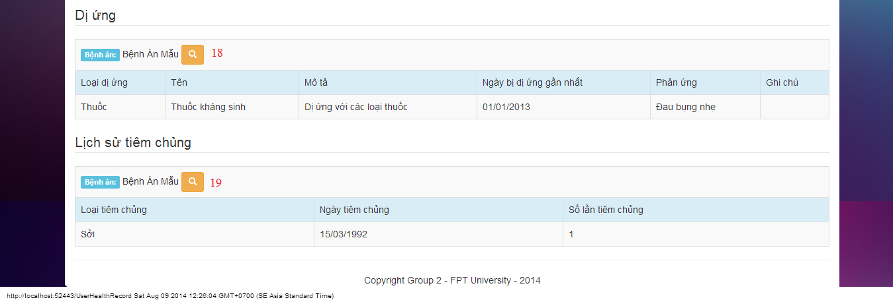

#### Objects and Actions

#### Data fields

|  |  |  |  |  |  |  |
| --- | --- | --- | --- | --- | --- | --- |
| **Field No** | **Field name** | **Type** | **Mandatory** | **Data type** | **Max length** | **Description** |
| 5 | Chiều cao | Textbox | No | String | 50 | Contain user’s height |
| 6 | Cân nặng | Textbox | No | String | 50 | Contain user’s weight |
| 7 | Màu mắt | Textbox | No | String | 50 | Contain user’s eye color |
| 8 | Màu tóc | Textbox | No | String | 50 | Contain user’s hair color |
| 9 | Nhóm máu | Textbox | No | String | 50 | Contain user’s blood type |
| 10 | Lượng đồ uống có cồn hàng tuần | Textbox | No | String | 50 | Contain user’s alcohol per week |
| 11 | Số năm uống | Textbox | No | String | 50 | Contain user’s alcohol number of year |
| 12 | Lượng thuốc hút hàng tuần | Textbox | No | String | 50 | Contain user’s smoke per week |
| 13 | Số năm hút | Textbox | No | String | 50 | Contain user’s smoke number of year |
| 14 | Tên loại thể thao | Textbox | No | String | 50 | Contain user’s sport name |
| 15 | Thời lượng tham gia hằng tuần | Textbox | No | String | 50 | Contain user’s sport per week |
| 16 | Tham gia khác | Textbox | No | String | 50 | Contain user’s exercise type |
| 17 | Thời lượng tham gia hằng tuần | Textbox | No | String | 50 | Contain user’s exercise per week |

#### Actions

|  |  |  |  |  |  |
| --- | --- | --- | --- | --- | --- |
| **Field No** | **Field name** | **Type** | **Action** | **Description** | **Validation** |
| 1 | 0 | Checkbox | On click | Click “0” to view table admin information |  |
| 2 | I | Checkbox | On click | Click “I” to edit table data admin information |  |
| 3 | O | Checkbox | On click | Click “0” to not next value after 300 second |  |
| 4 | I | Checkbox | On click | Click “0” to next value after 300 second |  |
| 18 | Bệnh án mẫu | Button | On click | Forward to “Details” medical profile page |  |
| 19 | Bệnh án mẫu | Button | On click | Forward to “Details” medical profile page |  |

### MEDICAL PROFILE SCREEN

#### Screen image

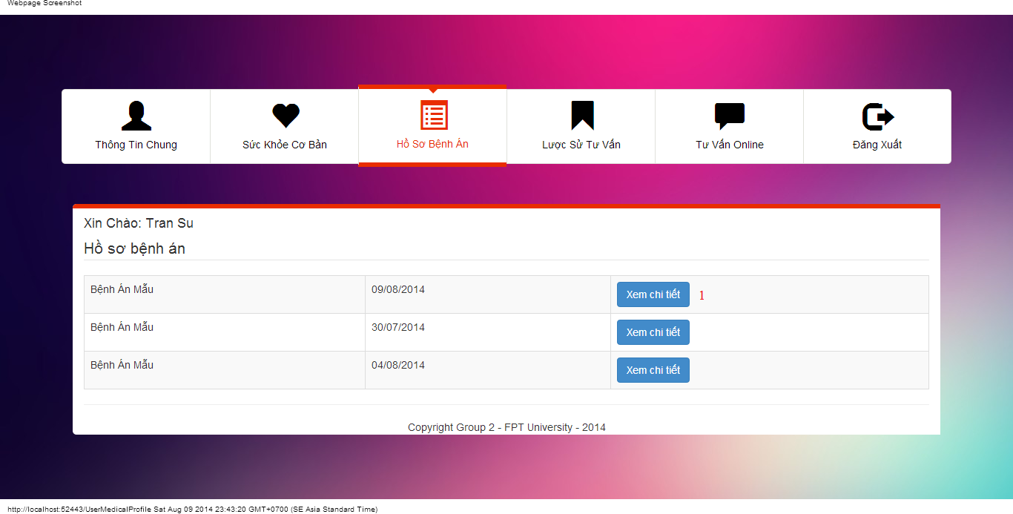

#### Objects and Actions

#### Data fields

|  |  |  |  |  |  |  |
| --- | --- | --- | --- | --- | --- | --- |
| **Field No** | **Field name** | **Type** | **Mandatory** | **Data type** | **Max length** | **Description** |

#### Actions

|  |  |  |  |  |  |
| --- | --- | --- | --- | --- | --- |
| **Field No** | **Field name** | **Type** | **Action** | **Description** | **Validation** |
| 1 | Xem chi tiết | Button | On click | Forward to “Details” medical profile page |  |

### VIEW CONSULT HISTORY SCREEN

#### Screen image

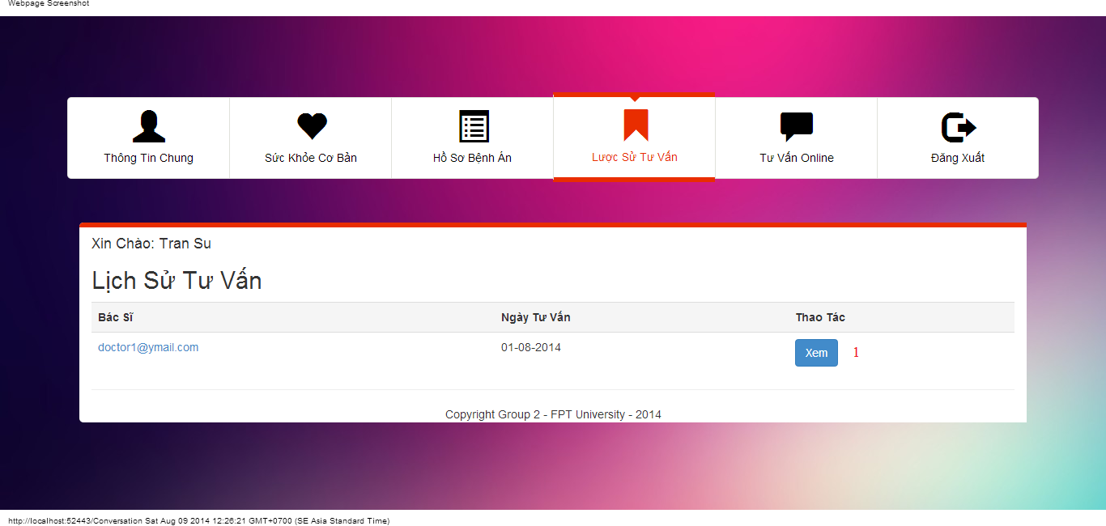

#### Objects and Actions

#### Data fields

|  |  |  |  |  |  |  |
| --- | --- | --- | --- | --- | --- | --- |
| **Field No** | **Field name** | **Type** | **Mandatory** | **Data type** | **Max length** | **Description** |

#### Actions

|  |  |  |  |  |  |
| --- | --- | --- | --- | --- | --- |
| **Field No** | **Field name** | **Type** | **Action** | **Description** | **Validation** |
| 1 | Xem | Button | On click | Forward to “ConversationDetails” page |  |

### USER CONVERSATION SCREEN

#### Screen image

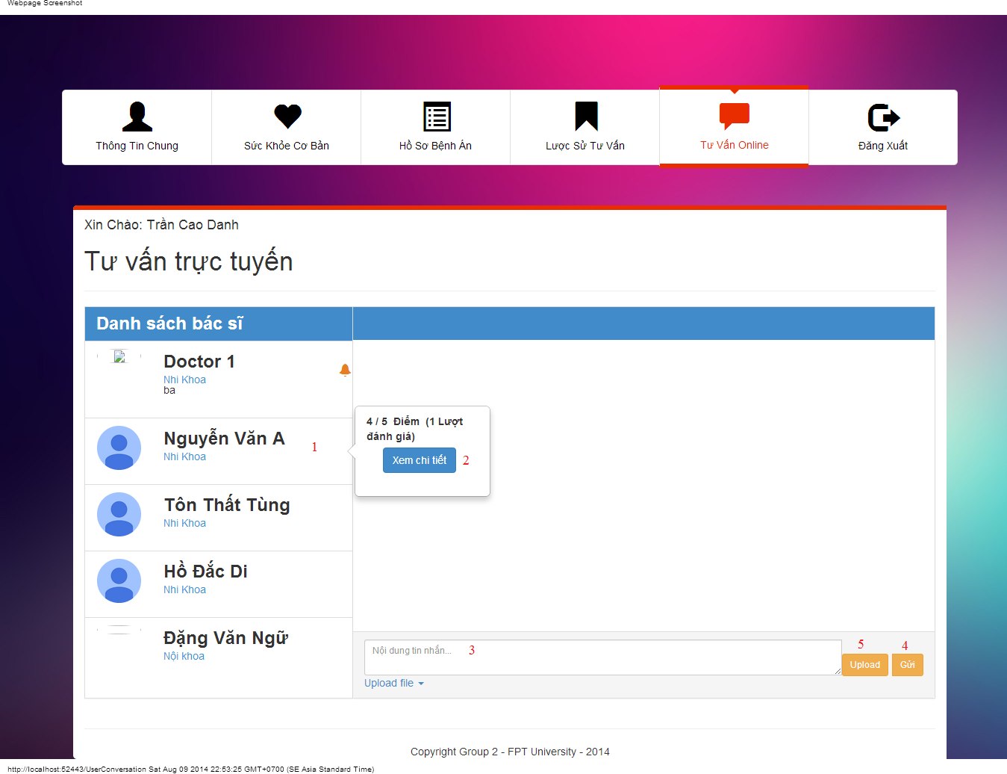

#### Objects and Actions

#### Data fields

|  |  |  |  |  |  |  |
| --- | --- | --- | --- | --- | --- | --- |
| **Field No** | **Field name** | **Type** | **Mandatory** | **Data type** | **Max length** | **Description** |
| 3 | Nội dung tin nhắn | Textbox | No | String |  | Contain user’s content conversation |

#### Actions

|  |  |  |  |  |  |
| --- | --- | --- | --- | --- | --- |
| **Field No** | **Field name** | **Type** | **Action** | **Description** | **Validation** |
| 1 | Danh sách bác sĩ | Link | On click | Click on a doctor to chat |  |
| 2 | Xem chi tiết | Button | On click | Forward to “Comment” page |  |
| 4 | Gửi | Button | On click | Submit inputted data to server |  |
| 5 | Upload | File | On click | Submit inputted file to server |  |

### USER COMMENT/RATING SCREEN

#### Screen image

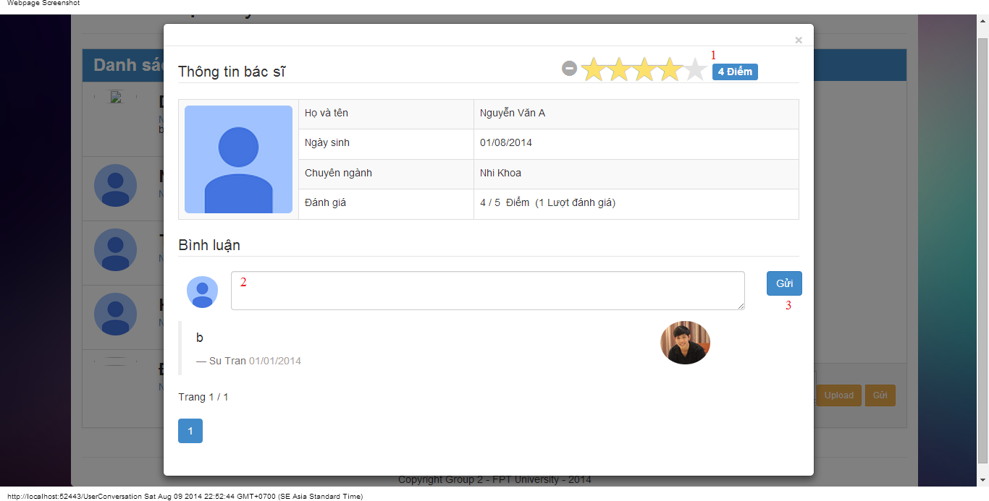

#### Objects and Actions

#### Data fields

|  |  |  |  |  |  |  |
| --- | --- | --- | --- | --- | --- | --- |
| **Field No** | **Field name** | **Type** | **Mandatory** | **Data type** | **Max length** | **Description** |
| 2 | Bình luận | Textbox | No | String |  | Comment of user |

#### Actions

|  |  |  |  |  |  |
| --- | --- | --- | --- | --- | --- |
| **Field No** | **Field name** | **Type** | **Action** | **Description** | **Validation** |
| 1 | Điểm | Button | On click | Summit inputted rate to server |  |
| 3 | Gửi | Button | On click | Summit inputted data to server |  |

## Database Design

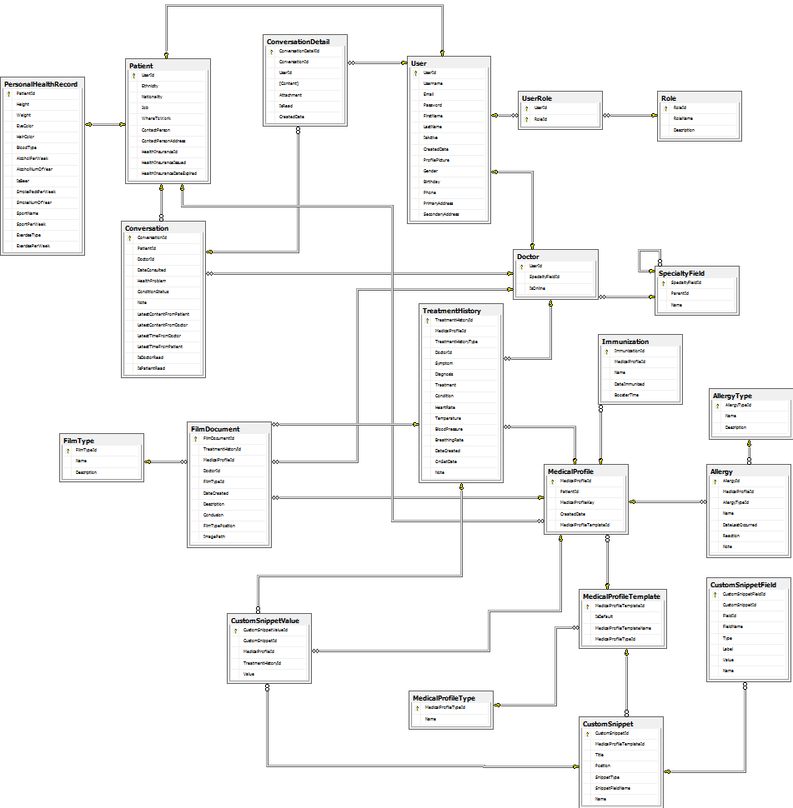

### User Table

|  |  |  |  |  |
| --- | --- | --- | --- | --- |
| **Field Name** | **Type** | **Null** | **P/F Key** | **Description** |
| UserId | int |  | PK | ID of the user |
| Username | nvarchar(50) |  |  | User name of the user |
| Email | nvarchar(50) |  |  | Email of the user |
| Password | nvarchar(50) |  |  | Password of the user |
| FirstName | nvarchar(50) | ✓ |  | First name of the user |
| LastName | nvarchar(50) | ✓ |  | Last name of the user |
| IsActive | Bit |  |  | Condition of the user’s account |
| CreatedDate | datetime |  |  | Created date of the user’s account |
| ProfilePicture | nvarchar(MAX) | ✓ |  | Profile picture name of the user |
| Gender | nvarchar(MAX) | ✓ |  | Gender of the user |
| Birthday | datetime | ✓ |  | Birthday of the user |
| Phone | nvarchar(MAX) | ✓ |  | Phone of the user |
| PrimaryAddress | nvarchar(MAX) | ✓ |  | Primary address of the user |
| SecondaryAddress | nvarchar(MAX) | ✓ |  | Secondary address of the user |

### UserRole Table

|  |  |  |  |  |
| --- | --- | --- | --- | --- |
| **Field Name** | **Type** | **Null** | **P/F Key** | **Description** |
| UserId | int |  | PK | ID of the user |
| RoleId | int |  | FK | ID of the role |

### Role Table

|  |  |  |  |  |
| --- | --- | --- | --- | --- |
| **Field Name** | **Type** | **Null** | **P/F Key** | **Description** |
| RoleId | int |  | PK | ID of the role |
| RoleName | nvarchar(MAX) |  |  | Name of the role |
| Description | nvarchar(MAX) |  |  | Description of the role |

### SpecialtyField Table

|  |  |  |  |  |
| --- | --- | --- | --- | --- |
| **Field Name** | **Type** | **Null** | **P/F Key** | **Description** |
| SpecialtyFieldId | int |  | PK | ID of the specialty field |
| ParentId | int |  | FK | ID of the parent specialty field |
| Name | nvarchar(MAX) |  |  | Description of the role |

### PersonalHealthRecord Table

|  |  |  |  |  |
| --- | --- | --- | --- | --- |
| **Field Name** | **Type** | **Null** | **P/F Key** | **Description** |
| PatientId | int |  | PK | ID of the patient |
| Height | float |  |  | Height of the patient |
| Weight | float |  |  | Weight of the patient |
| EyeColor | nvarchar(MAX) | ✓ |  | Eye color of the patient |
| HairColor | nvarchar(MAX) | ✓ |  | Hair color of the patient |
| BloodType | nvarchar(MAX) | ✓ |  | Blood type of the patient |
| AlcoholPerWeek | float |  |  | Drinking alcohol per week of the patient |
| AlcoholNumOfYear | int |  |  | Number of year that drink alcohol |
| IsBeer | bit |  |  | Is patient drinking beer? |
| SmokePackPerWeek | float |  |  | Smoke pack using per week |
| SmokeNumOfYear | int |  |  | Number of year that smoke |
| SportName | nvarchar(MAX) | ✓ |  | Sport name that patient plays |
| SportPerWeek | int |  |  | Times that patient plays sport |
| ExerciseType | nvarchar(MAX) | ✓ |  | Type of the exercise |
| ExercisePerWeek | int |  |  | Times of exercising per week |

### Patient Table

|  |  |  |  |  |
| --- | --- | --- | --- | --- |
| **Field Name** | **Type** | **Null** | **P/F Key** | **Description** |
| UserId | int |  | PK, FK | ID of the user |
| Ethnicity | nvarchar(MAX) | ✓ |  | Ethnicity of the patient |
| Nationality | nvarchar(MAX) | ✓ |  | Nationality of the patient |
| Job | nvarchar(MAX) | ✓ |  | Job of the patient |
| WhereToWork | nvarchar(MAX) | ✓ |  | Workplace of the patient |
| ContactPerson | nvarchar(MAX) | ✓ |  | Contact person of the patient |
| ContactPersonAddress | nvarchar(MAX) | ✓ |  | Contact person address of the patient |
| HealthInsuranceId | nvarchar(MAX) | ✓ |  | ID of health insurance |
| HealthInsuranceIssued | datetime | ✓ |  | Health insurance issued |
| HealthInsuranceDateExpired | datetime | ✓ |  | Expiring date of health insurance |

### MedicalProfileType Table

|  |  |  |  |  |
| --- | --- | --- | --- | --- |
| **Field Name** | **Type** | **Null** | **P/F Key** | **Description** |
| MedicalProfileTypeId | int |  | PK | ID of the medical profile type |
| Name | nvarchar(MAX) | ✓ |  | Name of the medical profile type |

### MedicalProfileTemplate Table

|  |  |  |  |  |
| --- | --- | --- | --- | --- |
| **Field Name** | **Type** | **Null** | **P/F Key** | **Description** |
| MedicalProfileId | int |  | PK | ID of the medical profile |
| PatientId | bit |  | FK | ID of the patient |
| MedicalProfileKey | nvarchar(MAX) | ✓ |  | Medical profile key |
| CreatedDate | int |  |  | Created date of medical profile |
| MedicalProfileTemplateId | int |  |  | ID of the medical profile template |

### Immunization Table

|  |  |  |  |  |
| --- | --- | --- | --- | --- |
| **Field Name** | **Type** | **Null** | **P/F Key** | **Description** |
| ImmunizationId | int |  | PK | ID of the immunization |
| MedicalProfileId | int |  | FK | ID of the immunization |
| Name | nvarchar(MAX) | ✓ |  | Name of the immunization |
| DateImmunized | datetime |  |  | Immunized date |
| BoosterTime | int |  |  | Booster time |

### FilmType Table

|  |  |  |  |  |
| --- | --- | --- | --- | --- |
| **Field Name** | **Type** | **Null** | **P/F Key** | **Description** |
| FilmTypeId | int |  | PK | ID of the film type |
| Name | nvarchar(MAX) | ✓ |  | Name of the film type |
| Description | nvarchar(MAX) | ✓ |  | Description of the film type |

### FilmDocument Table

|  |  |  |  |  |
| --- | --- | --- | --- | --- |
| **Field Name** | **Type** | **Null** | **P/F Key** | **Description** |
| FilmDocumentId | int |  | PK | ID of the film document |
| TreatmentHistoryId | int | ✓ | FK | ID of the treatment history |
| MedicalProfileId | int | ✓ | FK | ID of the medical profile |
| DoctorId | int |  | FK | ID of the doctor |
| FilmTypeId | int |  | FK | ID of the film type |
| DateCreated | datetime |  |  | Created date of the film document |
| Description | nvarchar(MAX) | ✓ |  | Description of the film document |
| Conclusion | nvarchar(MAX) | ✓ |  | Conclusion of the film document |
| FilmTypePosition | int |  |  | Position of the film type |
| ImagePath | nvarchar(MAX) | ✓ |  | Path of the image |

### Doctor Table

|  |  |  |  |  |
| --- | --- | --- | --- | --- |
| **Field Name** | **Type** | **Null** | **P/F Key** | **Description** |
| UserId | int |  | PK | ID of the user |
| SpecialtyFieldId | int |  | FK | ID of the specialty |
| IsOnline | bit |  |  | Online condition of the user |
| Rating | float |  |  | Rating that the doctor is rated |
| Votes | int |  |  | Number of rating |

### CustomSnippetValue Table

|  |  |  |  |  |
| --- | --- | --- | --- | --- |
| **Field Name** | **Type** | **Null** | **P/F Key** | **Description** |
| CustomSnippetValueId | int |  | PK | ID of the custom snippet value |
| CustomSnippetId | int |  | FK | ID of the custom snippet |
| MedicalProfileId | int |  | FK | ID of the medical profile |
| TreatmentHistoryId | int |  | FK | ID of the treatment history |
| Value | nvarchar(MAX) |  |  | Value of the custom snippet |

### TreatmentHistory Table

|  |  |  |  |  |
| --- | --- | --- | --- | --- |
| **Field Name** | **Type** | **Null** | **P/F Key** | **Description** |
| TreatmentHistoryId | int |  | PK | ID of the treatment history |
| MedicalProfileId | int |  | FK | ID of the medical profile |
| TreatmentHistoryType | int |  | FK | Treatment history type |
| DoctorId | int |  | FK | ID of the doctor |
| Symptom | nvarchar(MAX) | ✓ |  | Symptom of the patient |
| Diagnosis | nvarchar(MAX) | ✓ |  | Diagnosis of the patient |
| Treatment | nvarchar(MAX) | ✓ |  | Treatment of the patient |
| Condition | nvarchar(MAX) | ✓ |  | Condition of the patient |
| HeartRate | nvarchar(MAX) | ✓ |  | Heart rate of the patient |
| Temperature | nvarchar(MAX) | ✓ |  | Temperature of the patient |
| BloodPressure | nvarchar(MAX) | ✓ |  | Blood pressure of the patient |
| BreathingRate | nvarchar(MAX) | ✓ |  | Breathing rate of the patient |
| DateCreated | datetime |  |  | Created date of the treatment history |
| OnSetDate | datetime |  |  | Set date of the treatment history |
| Note | nvarchar(MAX) | ✓ |  | Note of the treatment history |

### CustomSnippetField Table

|  |  |  |  |  |
| --- | --- | --- | --- | --- |
| **Field Name** | **Type** | **Null** | **P/F Key** | **Description** |
| CustomSnippetFieldId | int |  | PK | ID of the custom snippet field |
| CustomSnippetId | int |  | FK | ID of the custom snippet |
| FieldId | nvarchar(MAX) | ✓ |  | ID of the field |
| FieldName | nvarchar(MAX) | ✓ |  | Name of the custom snippet field |
| Type | nvarchar(MAX) | ✓ |  | Type of the custom snippet field |
| Label | nvarchar(MAX) | ✓ |  | Label of the custom snippet field |
| Value | nvarchar(MAX) | ✓ |  | Value of the custom snippet field |
| Name | nvarchar(MAX) | ✓ |  | Name of the custom snippet field |

### CustomSnippet Table

|  |  |  |  |  |
| --- | --- | --- | --- | --- |
| **Field Name** | **Type** | **Null** | **P/F Key** | **Description** |
| CustomSnippetId | int |  | PK | ID of the custom snippet |
| MedicalProfileTemplateId | int |  | FK | ID of the medical profile template |
| Name | nvarchar(MAX) | ✓ |  | Name of the custom snippet |
| Title | nvarchar(MAX) | ✓ |  | Title of the custom snippet |
| Position | int |  |  | Position of the custom snippet |
| SnippetType | int |  |  | Type of the snippet |
| SnippetFieldName | nvarchar(MAX) | ✓ |  | Name of the snippet field |
| ParentId | int |  |  | ID of the parent custom snippet |
| PositionInTable | int |  |  | Position in tabale |

### ConversationDetail Table

|  |  |  |  |  |
| --- | --- | --- | --- | --- |
| **Field Name** | **Type** | **Null** | **P/F Key** | **Description** |
| ConversationDetailId | int |  | PK | ID of the conversation detail |
| ConversationId | int |  | FK | ID of the conversation |
| UserId | int |  | FK | ID of the user |
| [Content] | nvarchar(MAX) | ✓ |  | Content of the conversation |
| Attachment | nvarchar(MAX) | ✓ |  | File attachment |
| IsRead | bit |  |  | Send message condition |
| CreatedDate | datetime |  |  | Created date of the conversation |

### Conversation Table

|  |  |  |  |  |
| --- | --- | --- | --- | --- |
| **Field Name** | **Type** | **Null** | **P/F Key** | **Description** |
| ConversationId | int |  | PK | ID of the conversation |
| PatientId | int |  | FK | ID of the patient |
| DoctorId | int |  | FK | ID of the doctor |
| DateConsulted | datetime |  |  | Consulted date of the conversation |
| HealthProblem | nvarchar(MAX) | ✓ |  | Health problem of the conversation |
| ConditionStatus | nvarchar(MAX) | ✓ |  | Condition status |
| Note | nvarchar(MAX) | ✓ |  | Note of the conversation |
| LatestContentFromPatient | nvarchar(MAX) | ✓ |  | Latest content from the patient |
| LatestContentFromDoctor | nvarchar(MAX) | ✓ |  | Latest content from the doctor |
| LatestTimeFromDoctor | datetime |  |  | Latest time from the doctor |
| LatestTimeFromPatient | datetime |  |  | Latest time from the patient |
| IsDoctorRead | bit |  |  | Check message whether is read by the doctor |
| IsPatientRead | bit |  |  | Check message whether is read by the patient |

### Comment Table

|  |  |  |  |  |
| --- | --- | --- | --- | --- |
| **Field Name** | **Type** | **Null** | **P/F Key** | **Description** |
| CommentId | int |  | PK | ID of the comment |
| DoctorId | int |  | FK | ID of the doctor |
| PatientId | int |  | FK | ID of the patient |
| [Content] | nvarchar(MAX) | ✓ |  | Content of the comment |
| PostedDate | datetime |  |  | Posted date of the comment |

### AllergyType Table

|  |  |  |  |  |
| --- | --- | --- | --- | --- |
| **Field Name** | **Type** | **Null** | **P/F Key** | **Description** |
| AllergyTypeId | int |  | PK | ID of the allergy type |
| Name | nvarchar(MAX) | ✓ | FK | Name of the allergy type |
| Description | nvarchar(MAX) | ✓ | FK | Description of the allergy type |

### Allergy Table

|  |  |  |  |  |
| --- | --- | --- | --- | --- |
| **Field Name** | **Type** | **Null** | **P/F Key** | **Description** |
| AllergyId | int |  | PK | ID of the allergy |
| MedicalProfileId | int |  | FK | ID of the medical profile |
| AllergyTypeId | int |  | FK | ID of the allergy type |
| Name | nvarchar(MAX) | ✓ |  | Name of the allergy |
| DateLastOccurred | datetime |  |  | Last occurred date of the allergy |
| Reaction | nvarchar(MAX) | ✓ |  | Reaction of the allergy |
| Note | nvarchar(MAX) | ✓ |  | Note of the allergy |